**CST8912 – Cloud Solution Architecture**

**Graded Lab Activity #6**

1. Distinguish between public-cloud, private-cloud, hybrid-cloud and multi-cloud solution design patterns. (2,5,6,7)

* Classify and describe the type of clouds available in the marketplace
* Identify the pros, cons, use cases, and pricing of each cloud computing service
* Examine the risks associated with each type of cloud computing service
* Assess security compliance requirements as part of the decision-making process

**Introduction:**

Azure Private Link provides private connectivity from a virtual network to Azure platform as a service (PaaS), customer-owned, or Microsoft partner services. It simplifies the network architecture and secures the connection between endpoints in Azure by eliminating data exposure to the public internet.

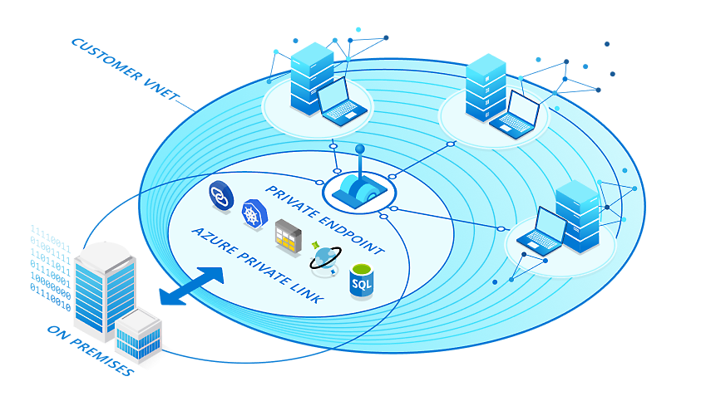

Private Endpoint is the key technology behind Private Link. Private Endpoint is a network interface that enables a private and secure connection between your virtual network and an Azure service. In other words, Private Endpoint is the network interface that replaces the resource's public endpoint.

Private Link gives you private access from your Azure virtual network to PaaS services and Microsoft Partner services in Azure. However, what if your company has created its own Azure services for your company's customers to consume? Is it possible to offer those customers a private connection to your company's services?

Yes, by using Azure Private Link Service. This service lets you offer Private Link connections to your custom Azure services. Consumers of your custom services can then access those services privately—that is, without using the internet—from their own Azure virtual networks.

When to use Private Link?  
You know what Private Link is and how it works. Now you need some criteria to help you evaluate whether Private Link is a suitable choice for your company. To help you make a decision, let's consider the following goals:

* Bringing Azure PaaS services into your virtual network
* Securing traffic between your company network and the Azure cloud
* Eliminating internet exposure for PaaS services
* Accessing Azure PaaS resources across networks
* Lowering the risk of data exfiltration
* Offering customers private access to company-created Azure services

**Purpose of this hands-on-lab that can be simulated for any CSP:**

Upon completion of this lab, you will be able to create, configure and test the private link for any CSP  
  
Azure Private endpoint is the fundamental building block for Private Link in Azure. It enables Azure resources, like virtual machines (VMs), to privately and securely communicate with Private Link resources such as Azure Storage.

**Create a Virtual network and Bastion Host**

1. In the portal, search for and select Virtual networks.

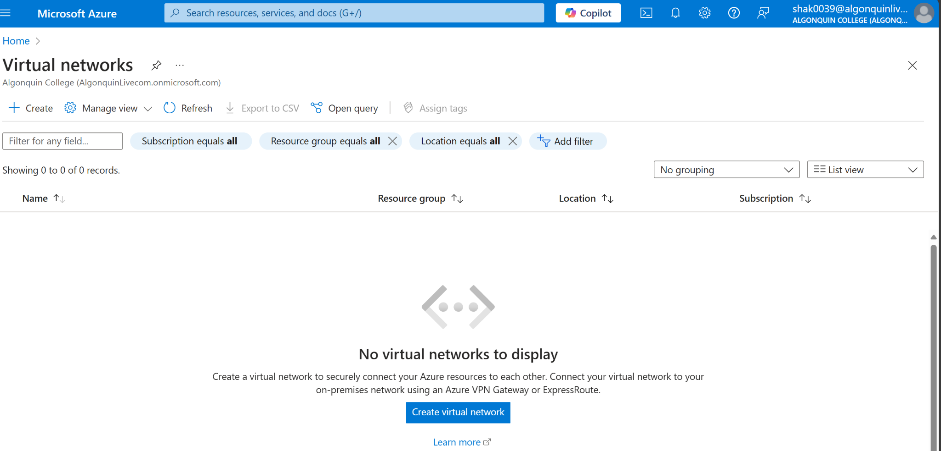

1. On the Virtual networks page, select + Create.

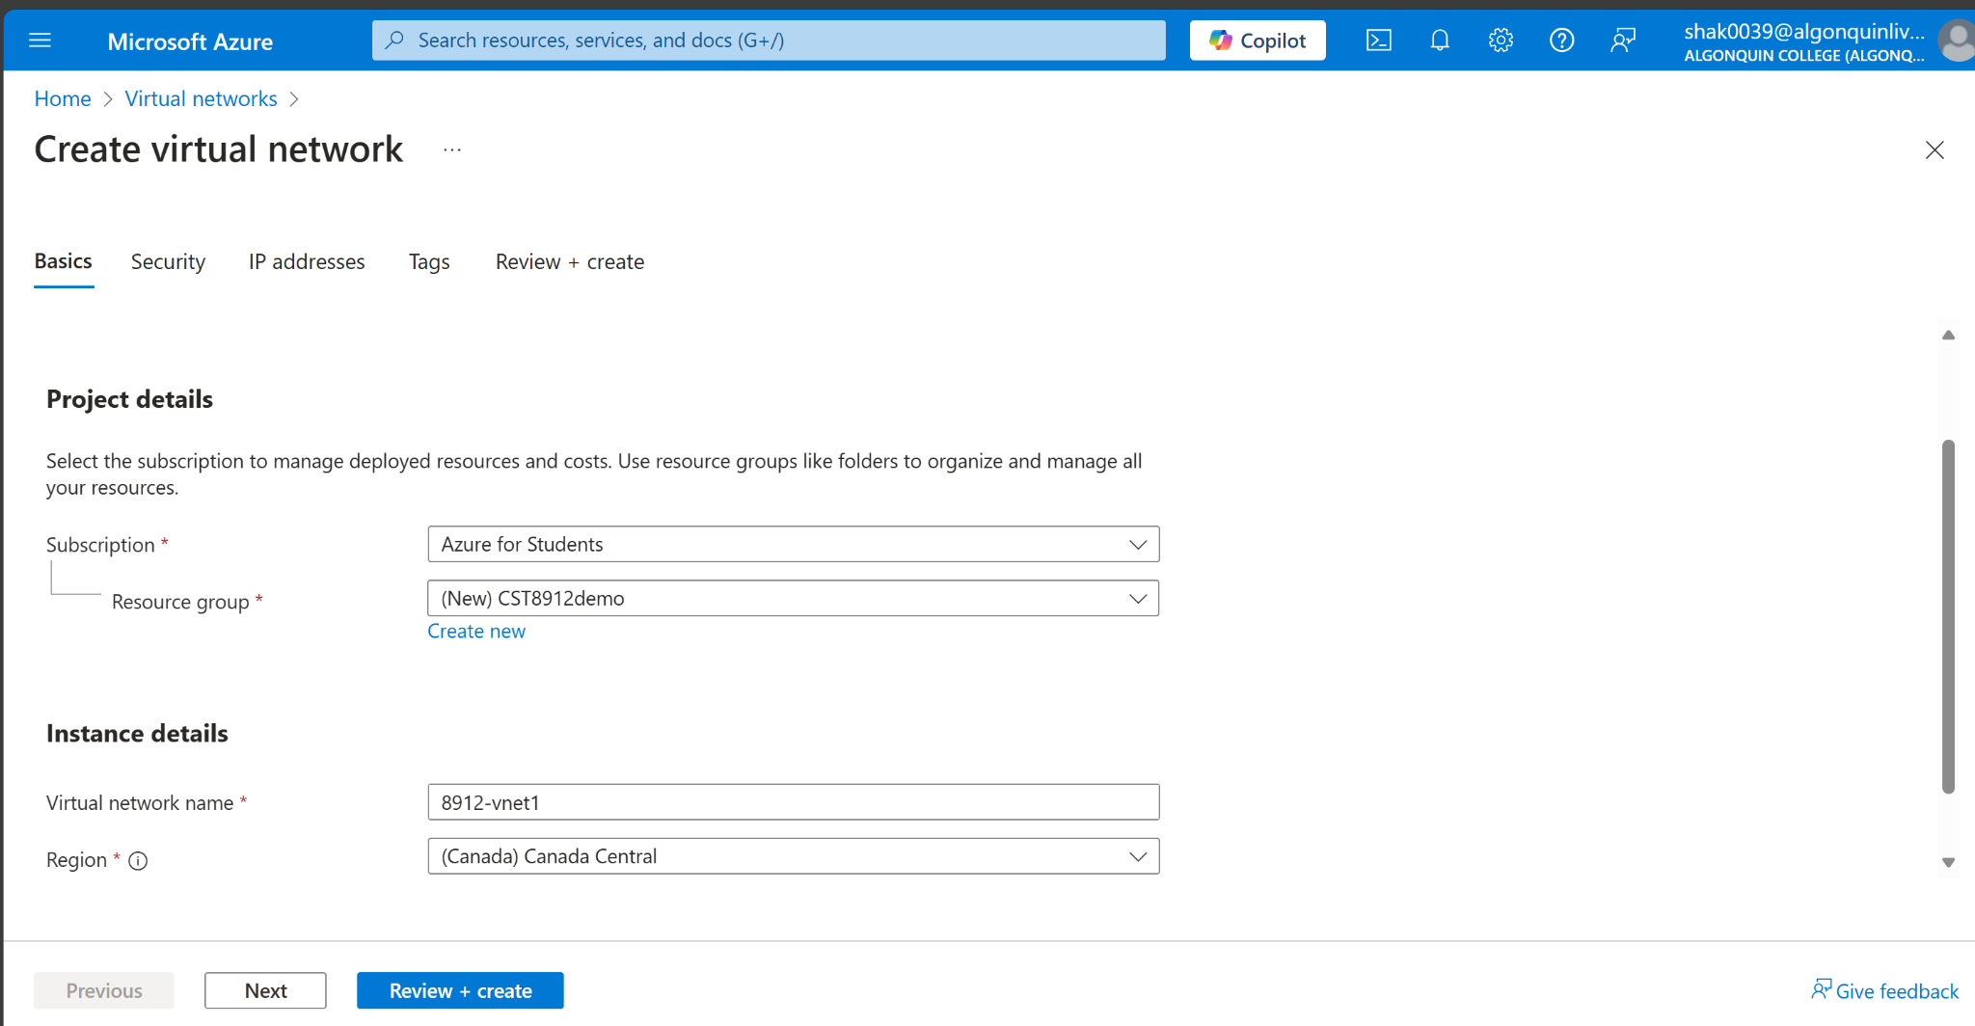

1. On the Basics tab of Create virtual network, enter or select the following information:

| **Setting** | **Value** |
| --- | --- |
| **Subscription** | Azure for students |
| **Resource Group** | CST8912demo |
| **Name** | 8912-vnet1 |
| **Region** | Canada Central |

1. Select Next to proceed to the Security tab.
2. Select Enable Bastion in the Azure Bastion section of the Security tab.

Azure Bastion uses your browser to connect to VMs in your virtual network over secure shell (SSH) or remote desktop protocol (RDP) by using their private IP addresses. The VMs don't need public IP addresses, client software, or special configuration

1. Enter or select the following information in Azure Bastion:

| **Setting** | **Value** |
| --- | --- |
| **Azure Bastion host name** | Enter Bastion8912 |
| **Azure Bastion public IP address** | Select **Create a public IP address**. Enter **public-ip** in Name. Select **OK**. |

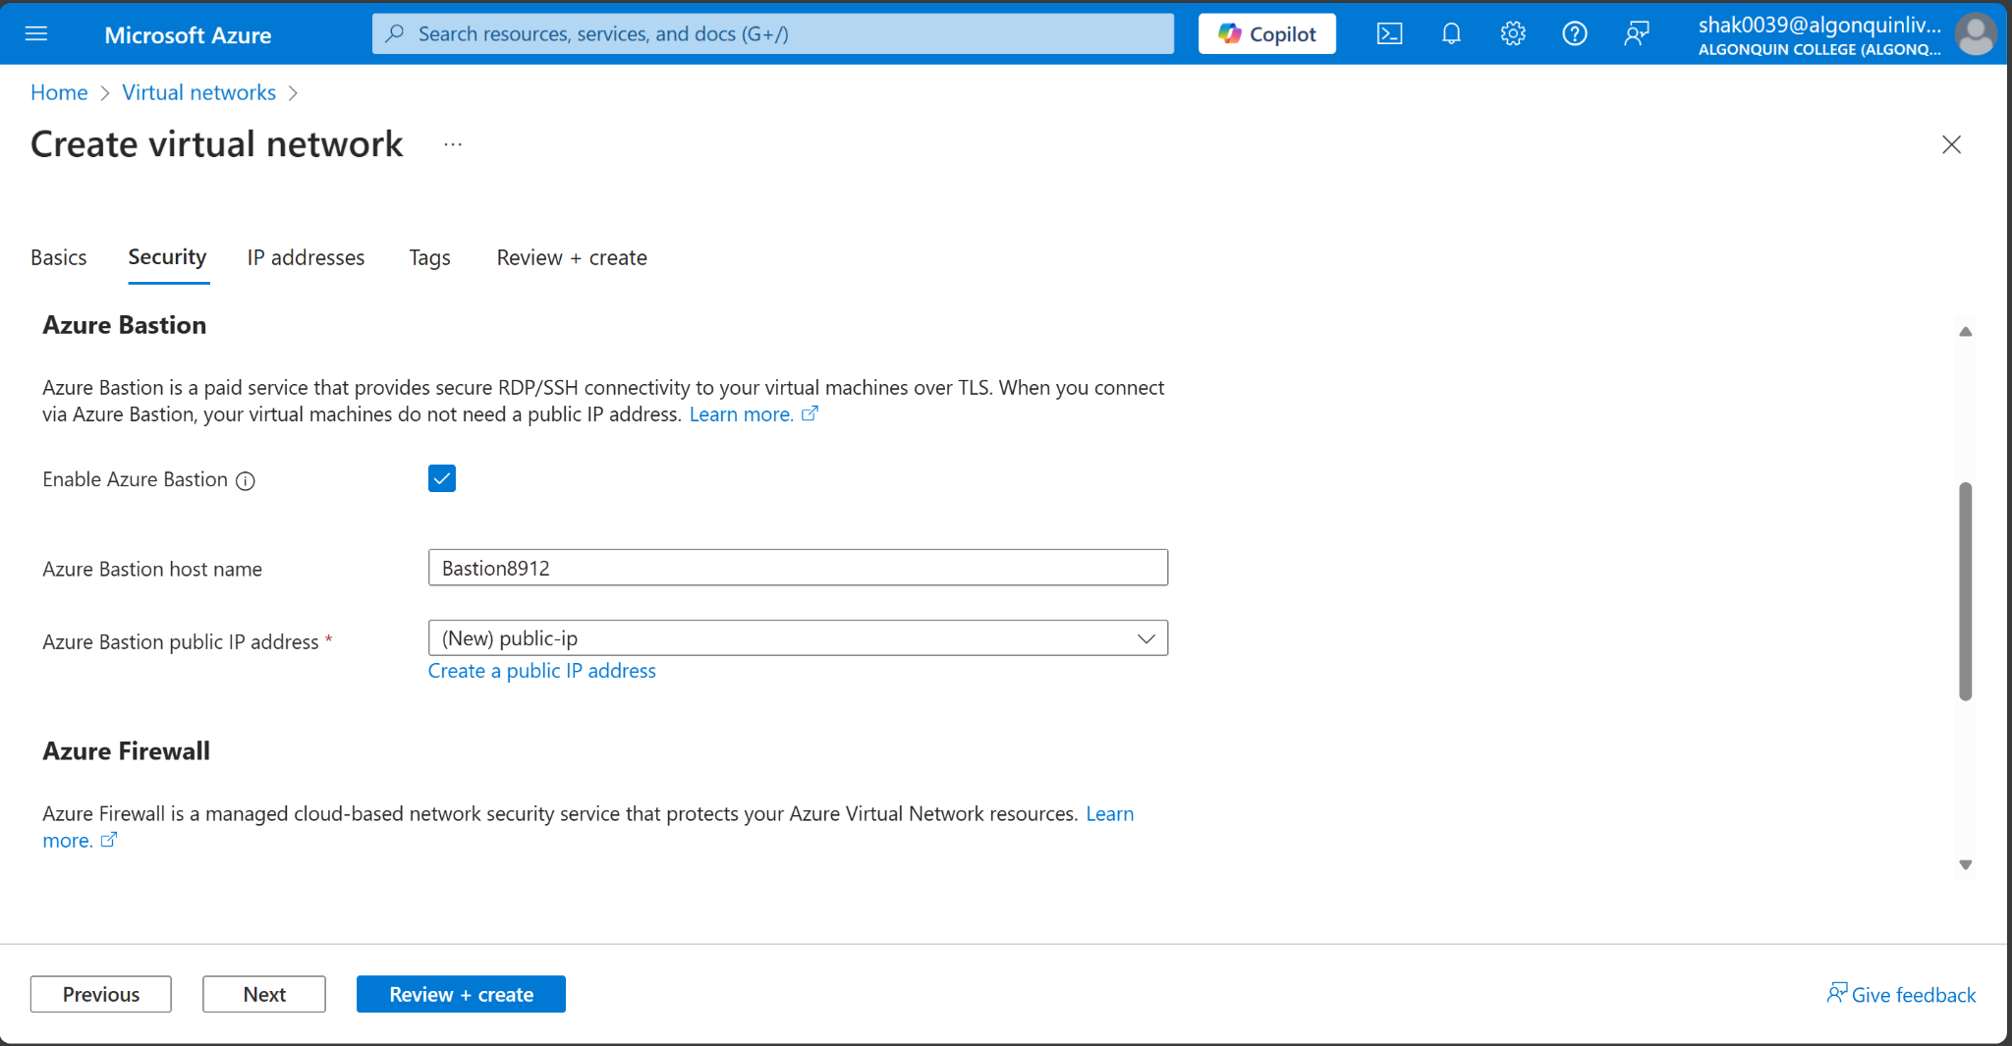

1. Select Next to proceed to the IP Addresses tab.
2. In the address space box in Subnets, select the default subnet.
3. In Edit subnet, enter or select the following information:

| **Setting** | **Value** |
| --- | --- |
| Subnet template | Leave the default **Default**. |
| Name | Subnet-1-8912 |
| IPv4 address range | Leave 10.0.0.0/16. |
| Starting address | Leave the default of 10.0.0.0. |
| Subnet size | Leave the default of /24(256 addresses). |

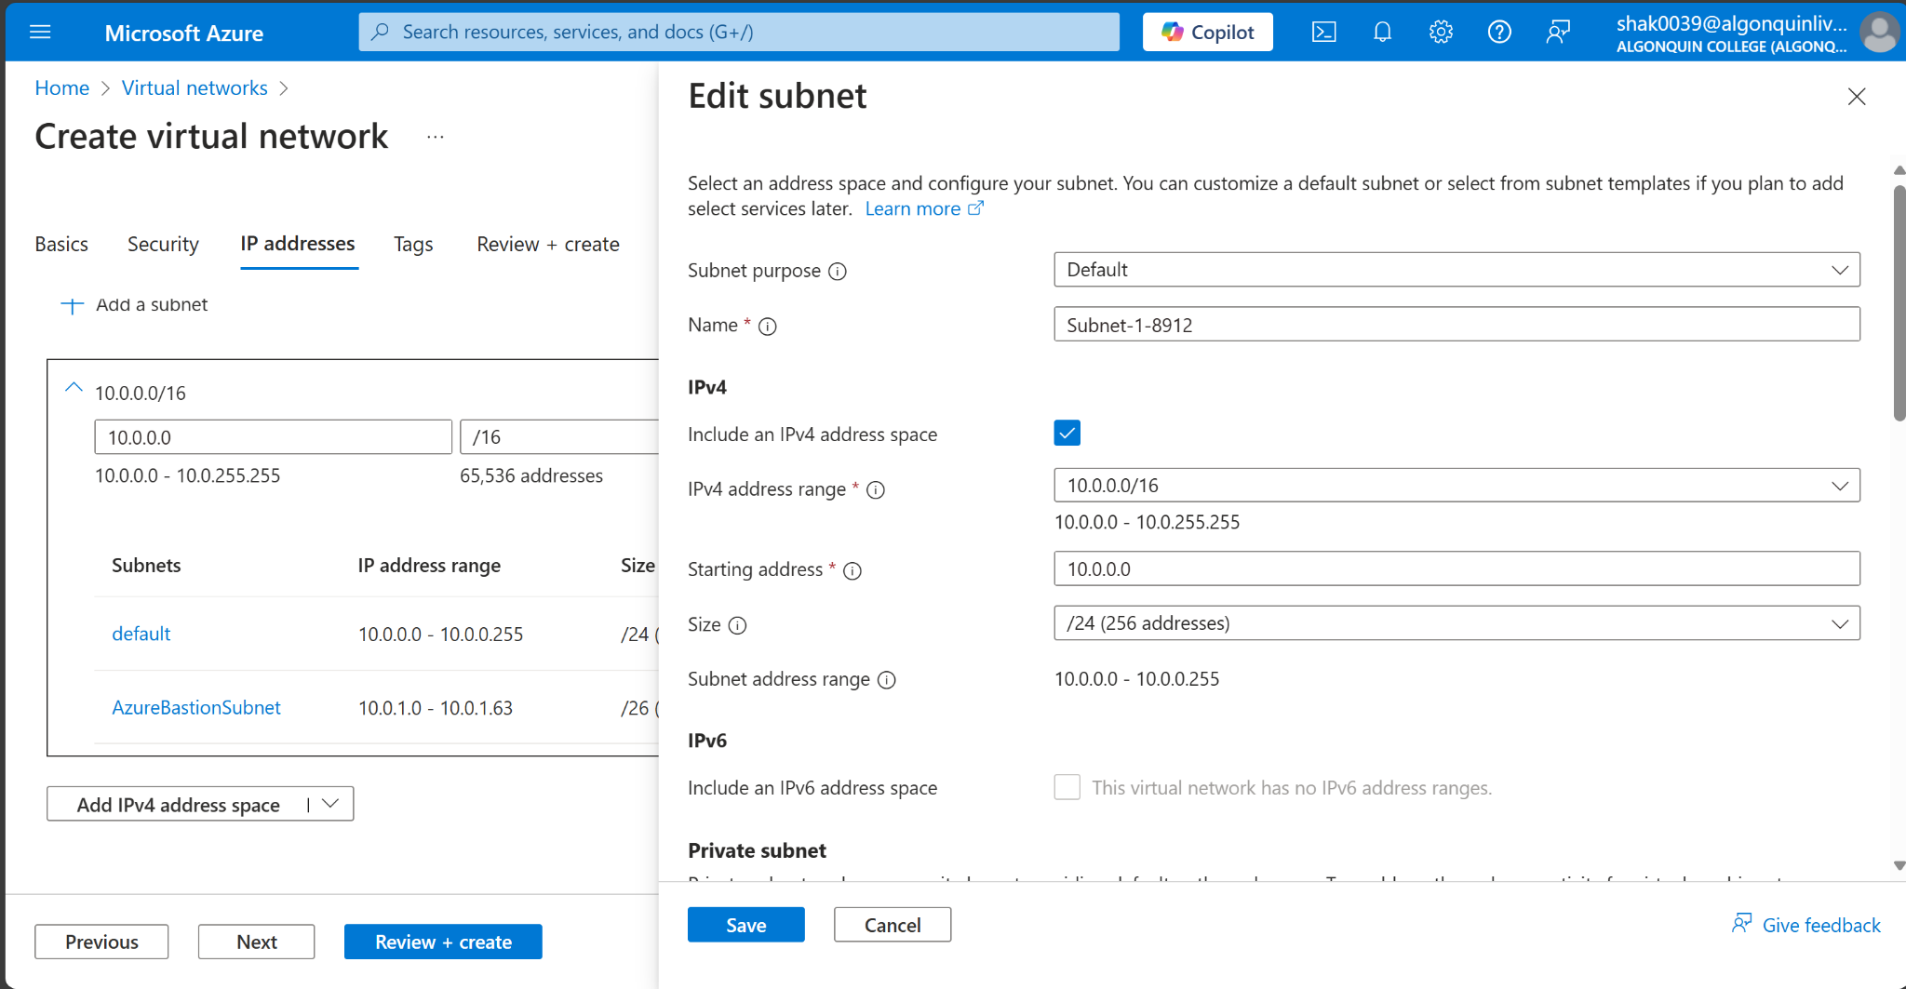

1. Select save

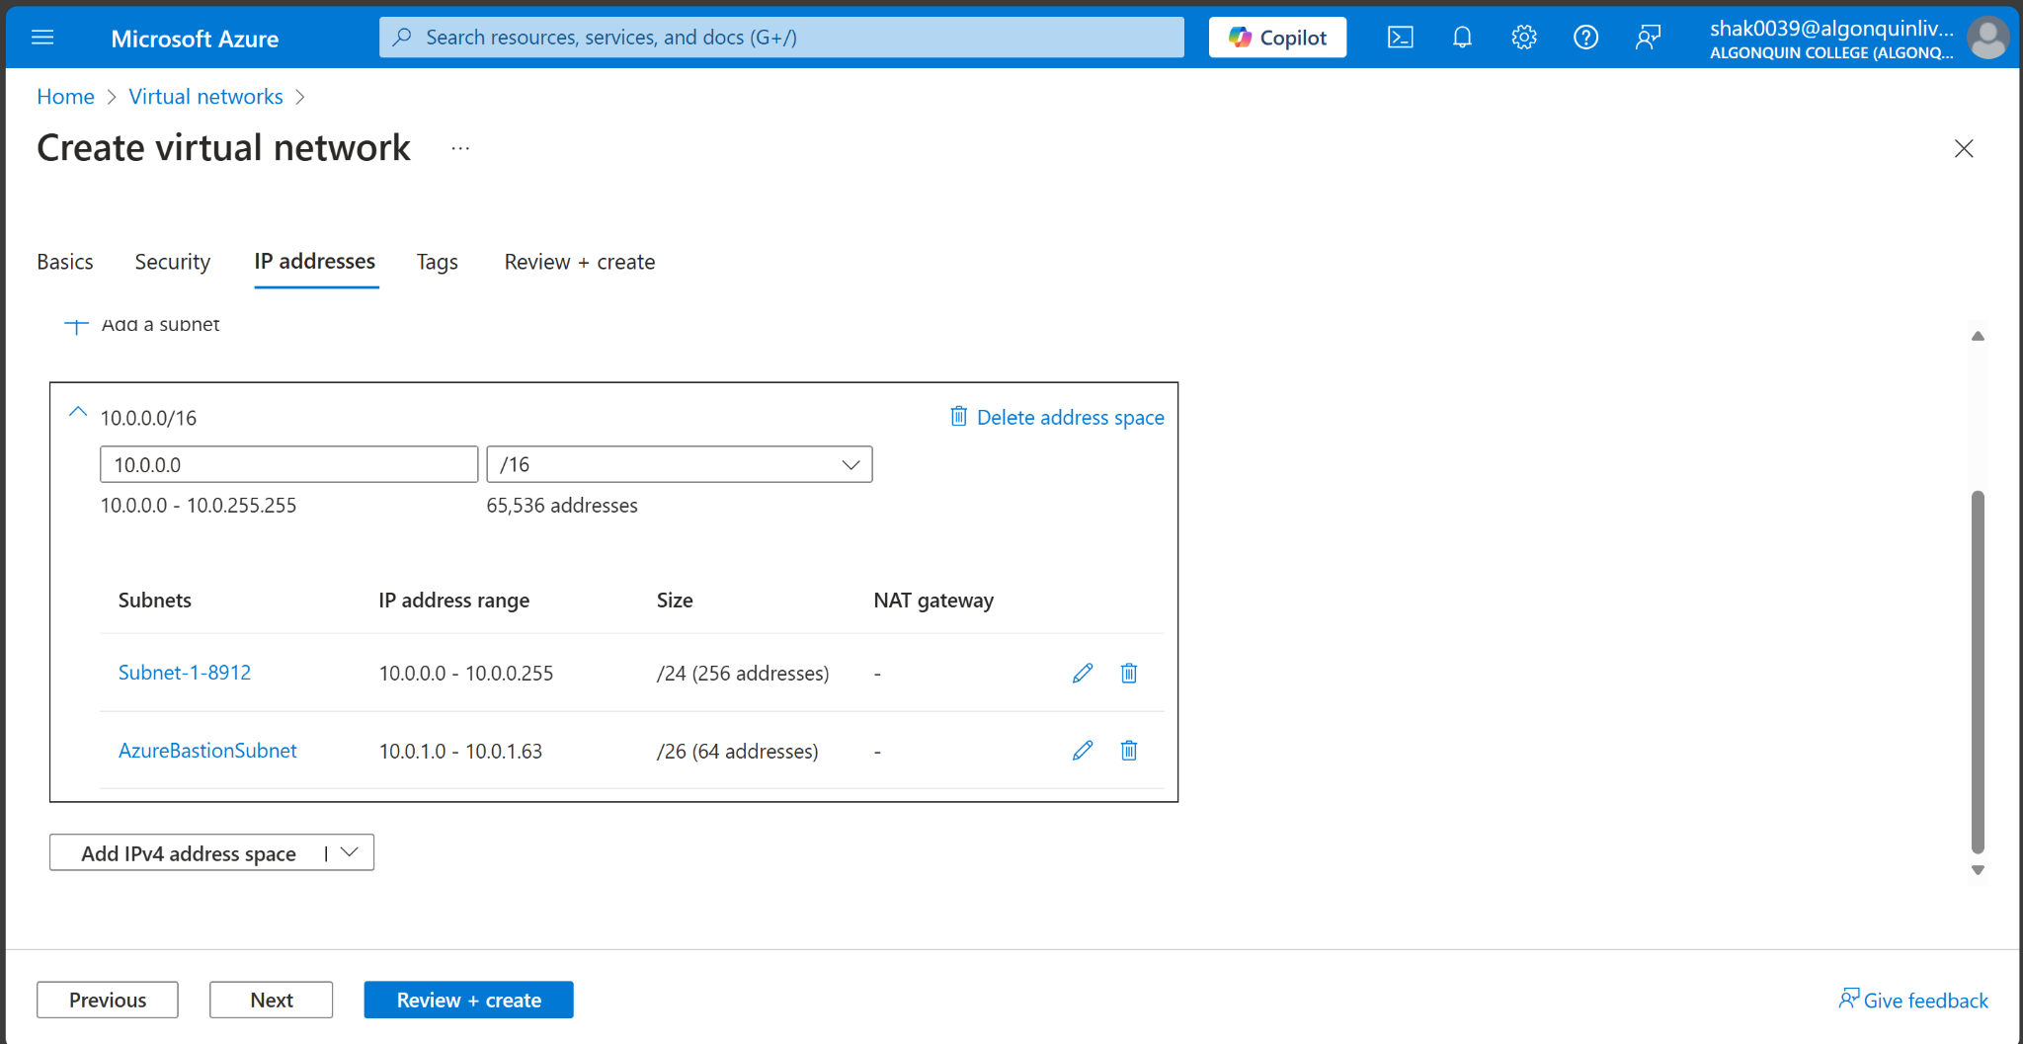

1. Create and review when the validation passes

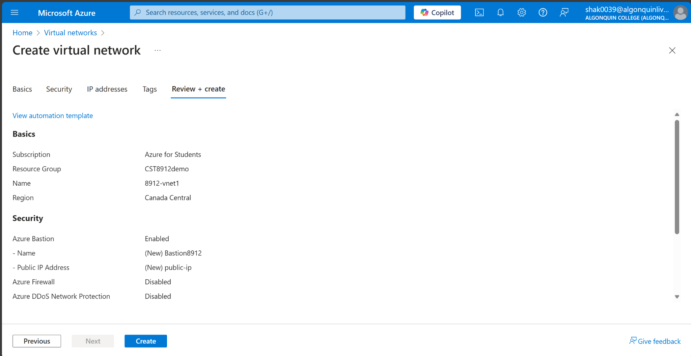

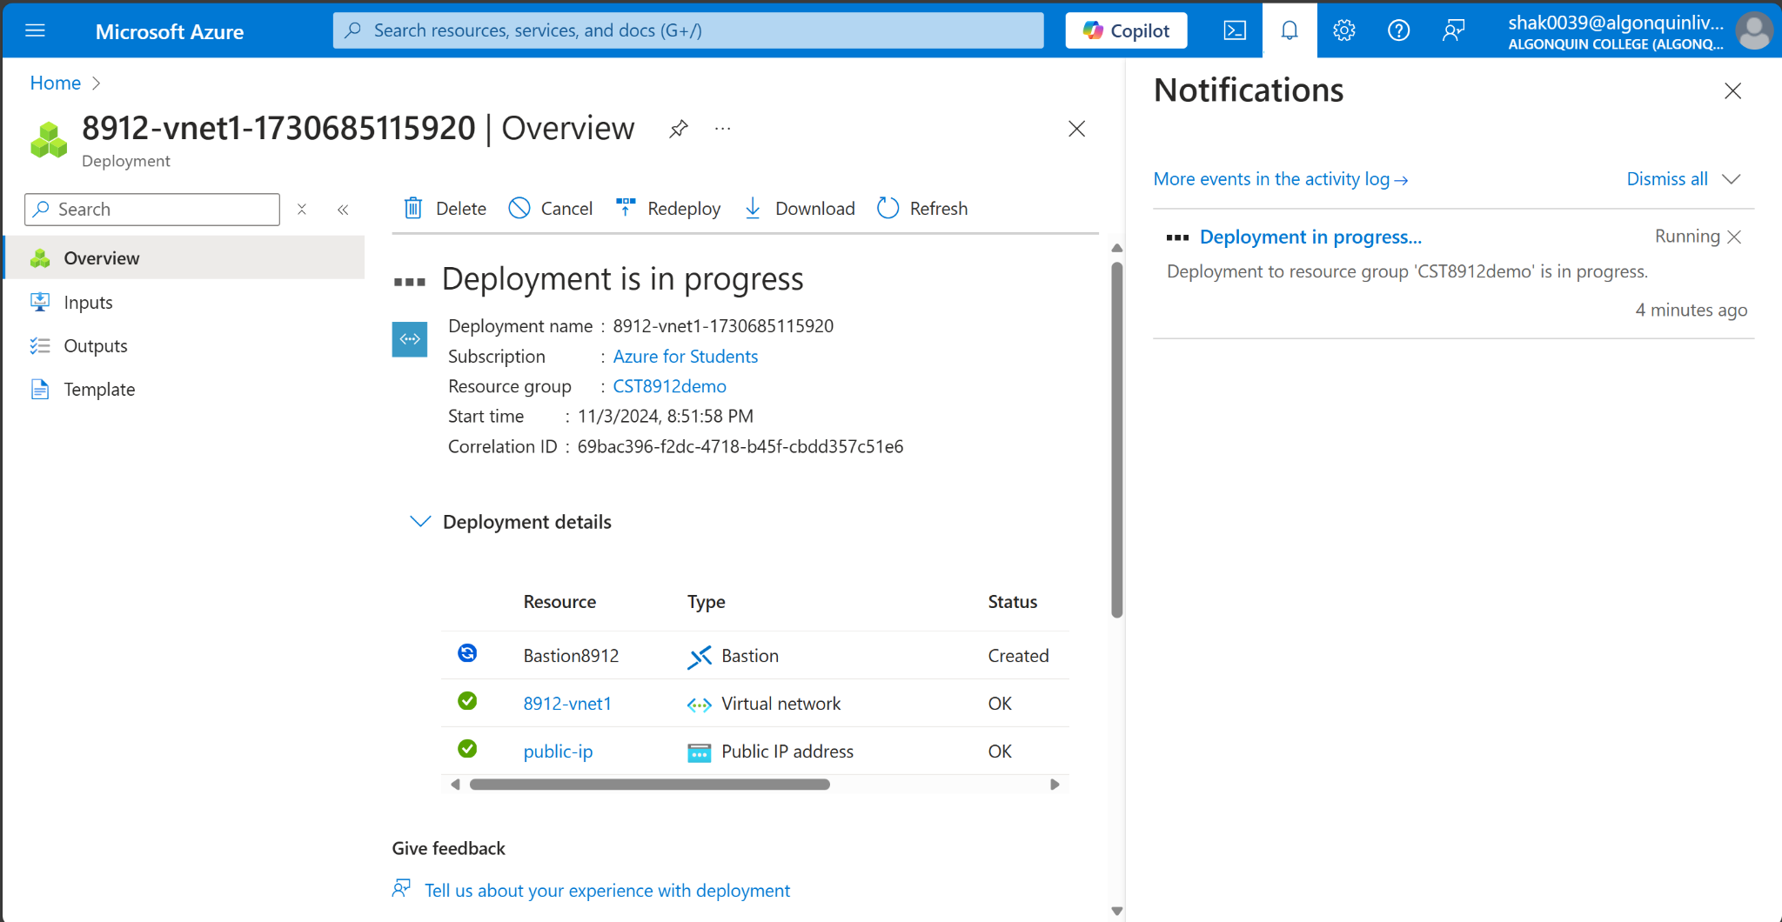

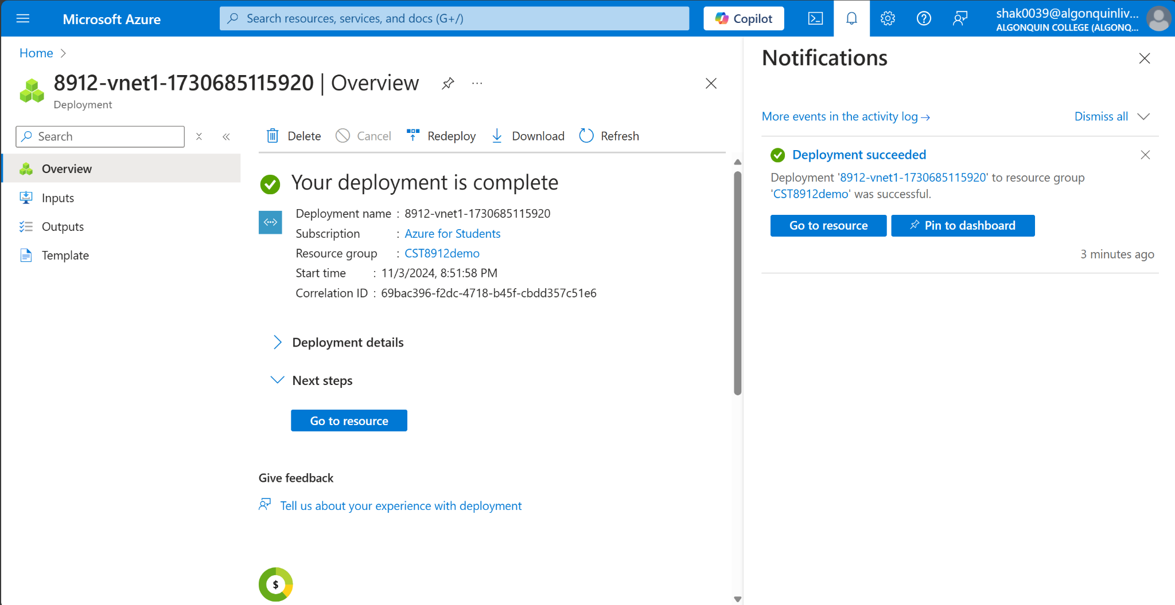

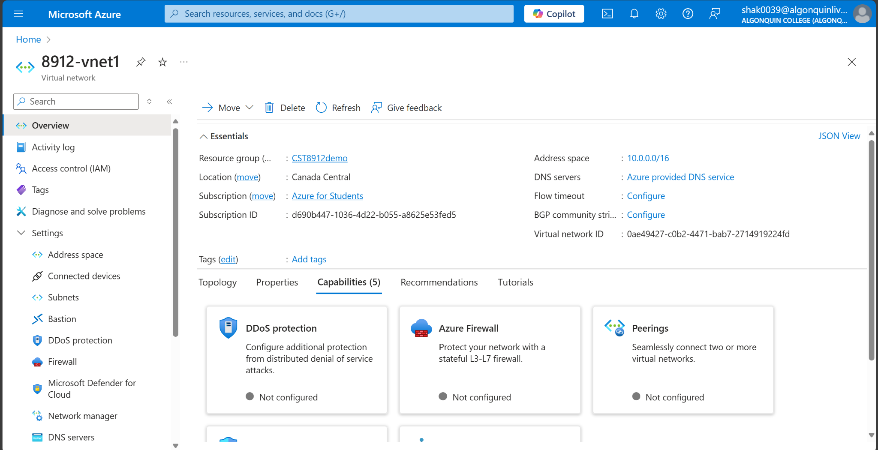

**Create a Storage Account**

1. In the search box at the top of the portal, enter Storage account. Select Storage accounts in the search results.

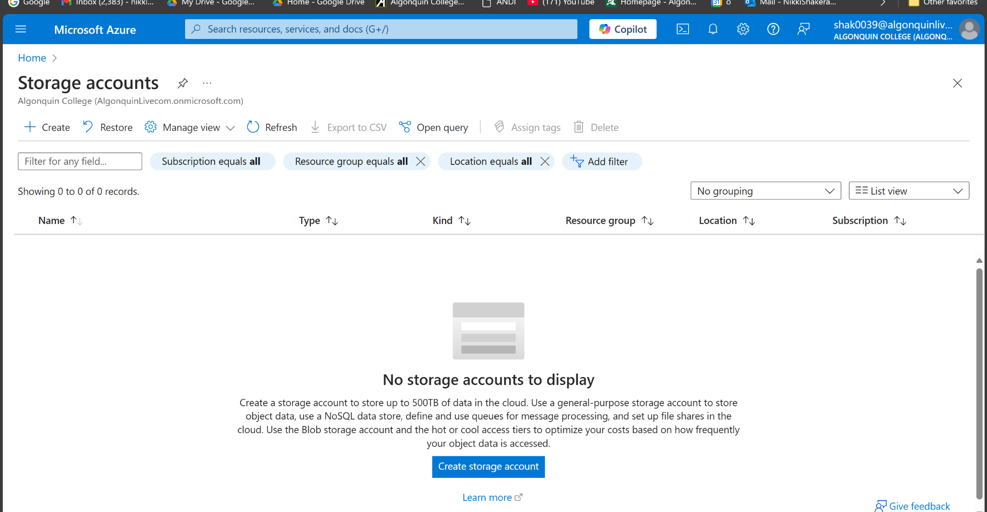

1. Select + Create.
2. In the Basics tab of Create a storage account enter or select the following information:

| **Setting** | **Value** |
| --- | --- |
| Subscription | Azure for students |
| Resource Group | CST8912demo |
| Storage Account Name | Storage1-8912 |
| Location | Canada Central |
| Performance | Standard |
| Redundancy | Local Redundant Storage (LRS) |

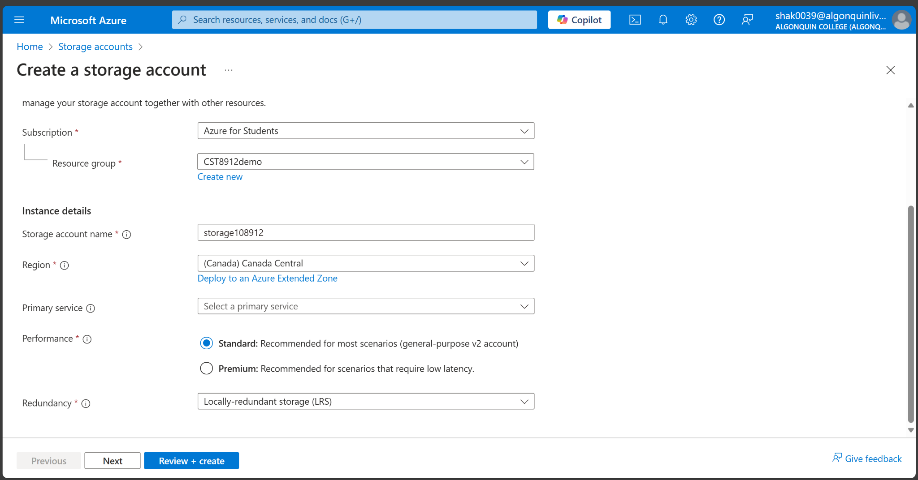

1. Select review

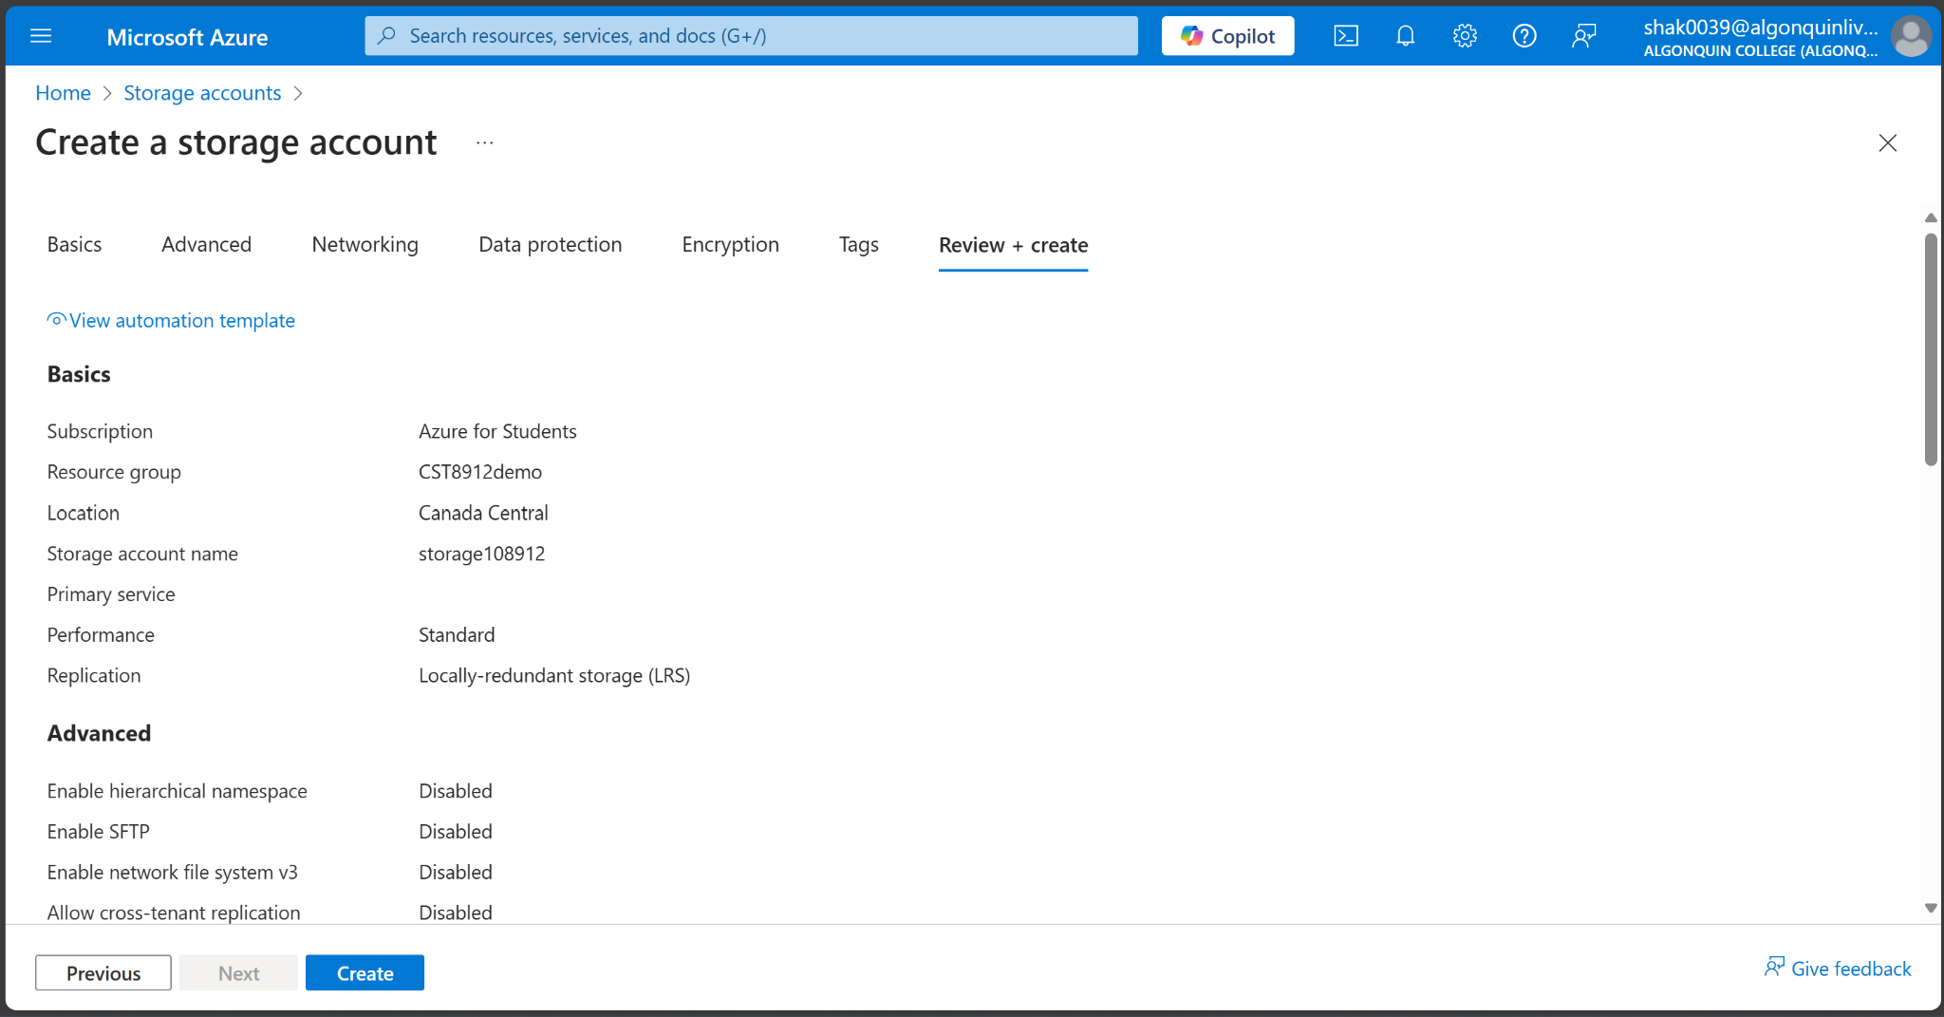

1. Select create

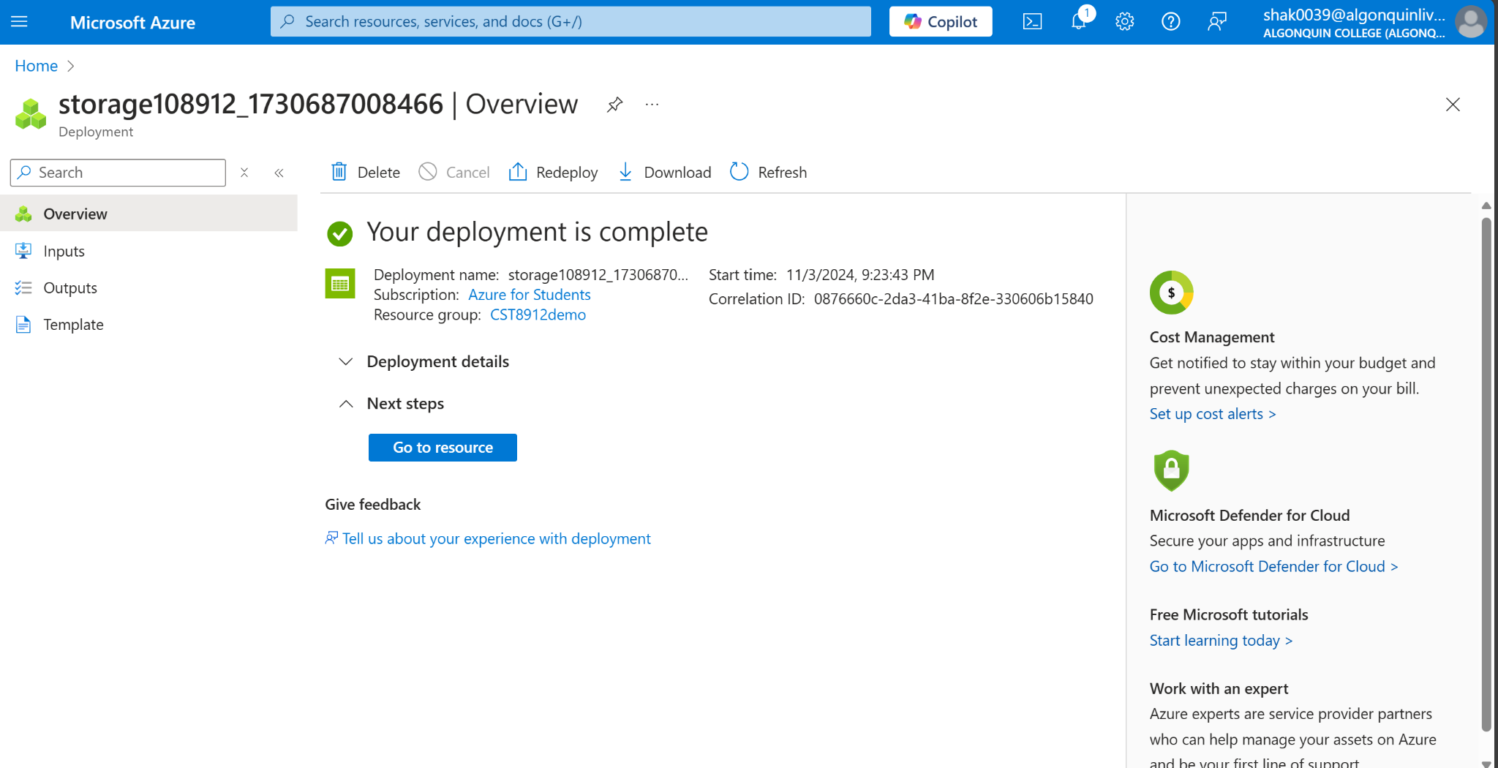

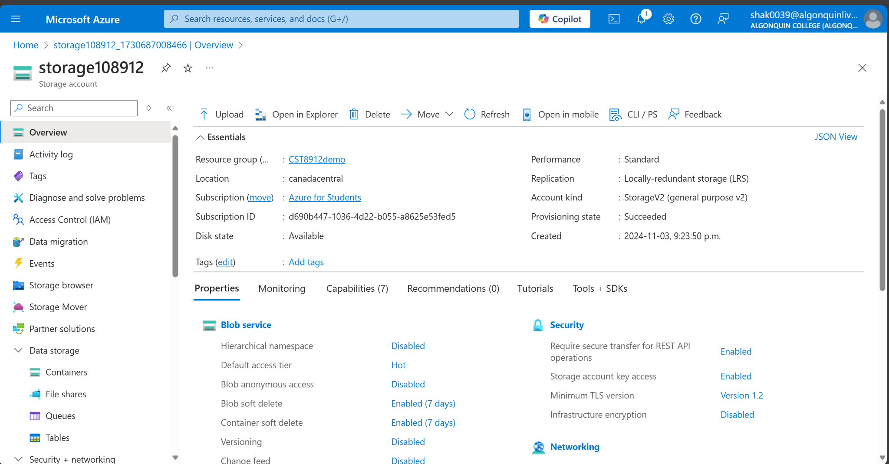

**Disable public access to storage account**

1. In the search box at the top of the portal, enter Storage account. Select Storage accounts in the search results.
2. Select storage1 or the name of your existing storage account.

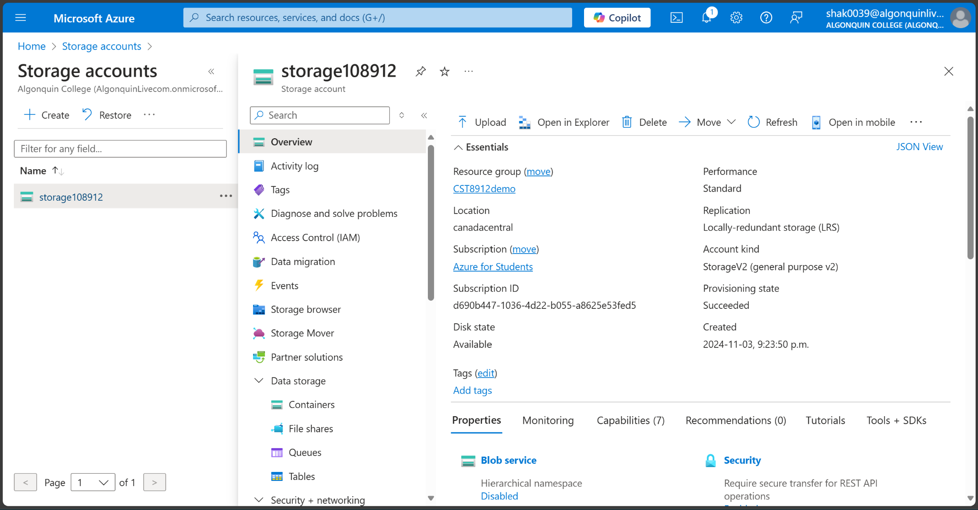

1. In Security + networking, select Networking.

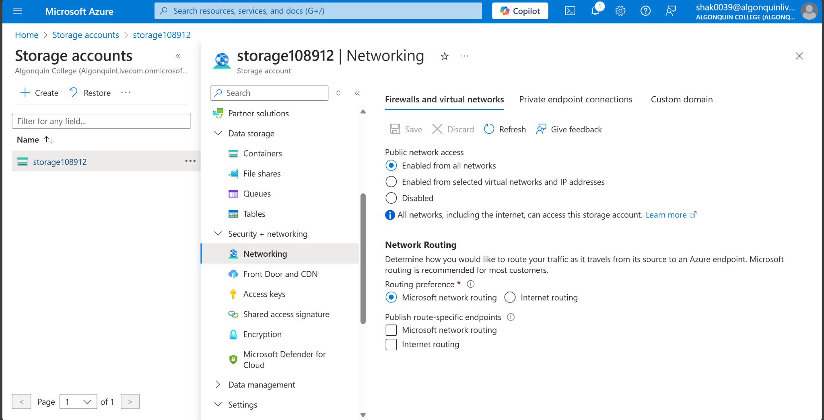

1. In the Firewalls and virtual networks tab in Public network access, select Disabled.

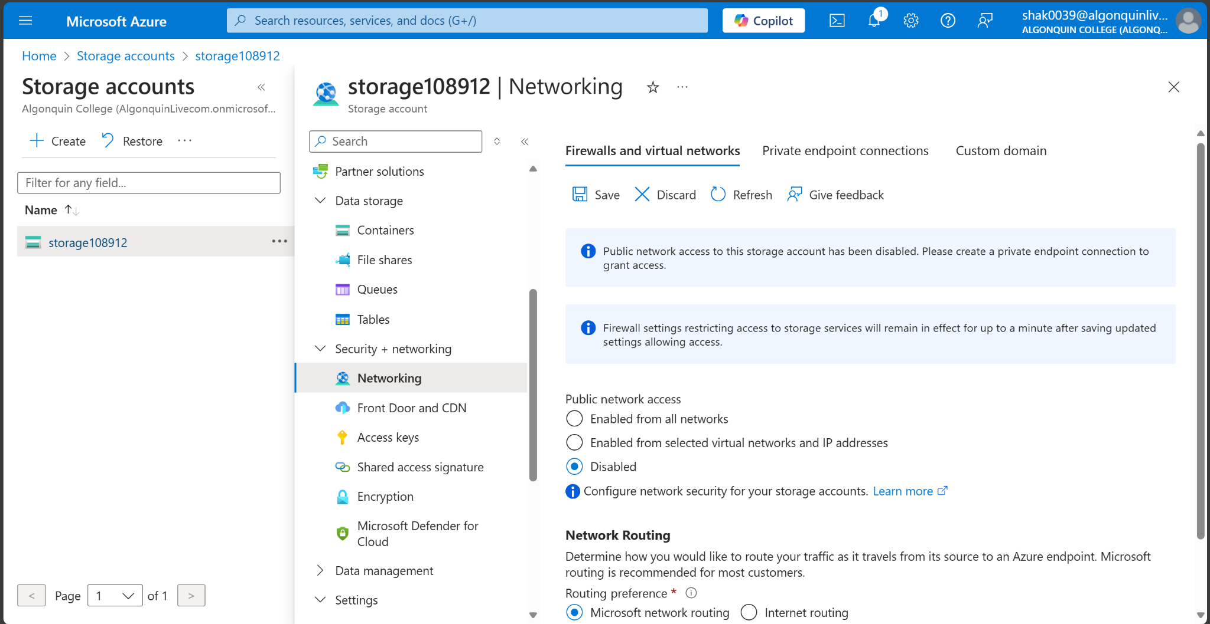

1. Select Save.

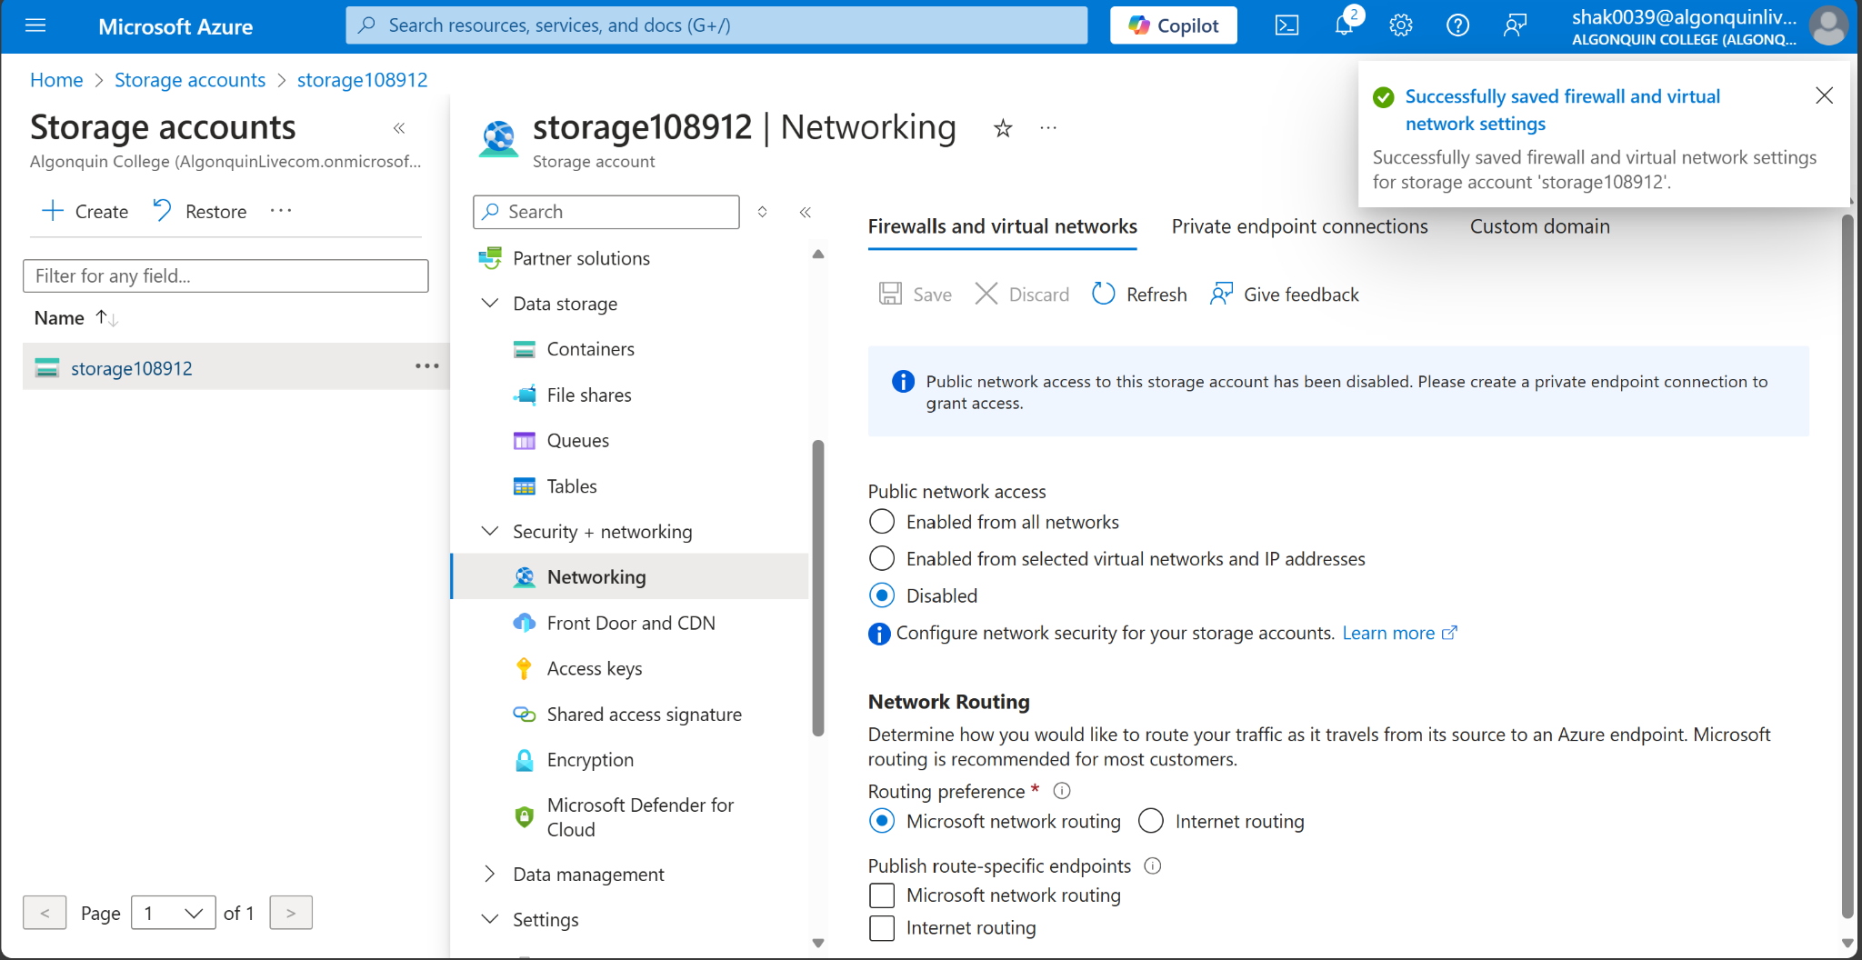

**Create private endpoint**

1. In the search box at the top of the portal, enter Private endpoint. Select Private endpoints.

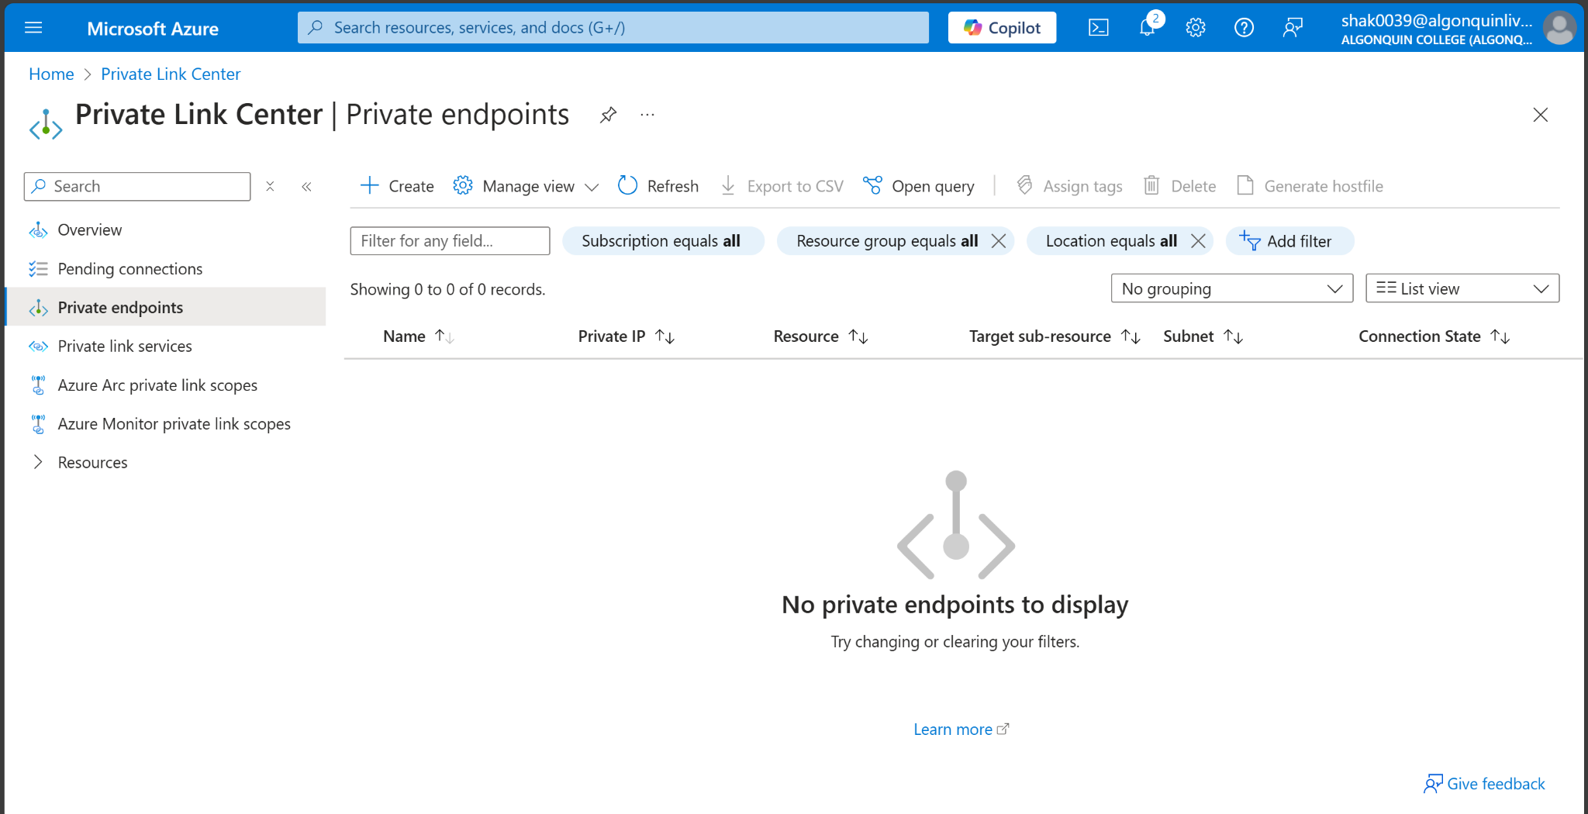

1. Select + Create in Private endpoints.
2. In the Basics tab of Create a private endpoint, enter or select the following information.

| **Setting** | **Value** |
| --- | --- |
| Subscription | Azure for students |
| Resource Group | CST8912demo |
| Name | Privateendpoint-8912 |
| Network Interface Name | Leave the default of **private-endpoint-nic**. |
| Region | Canada Central |

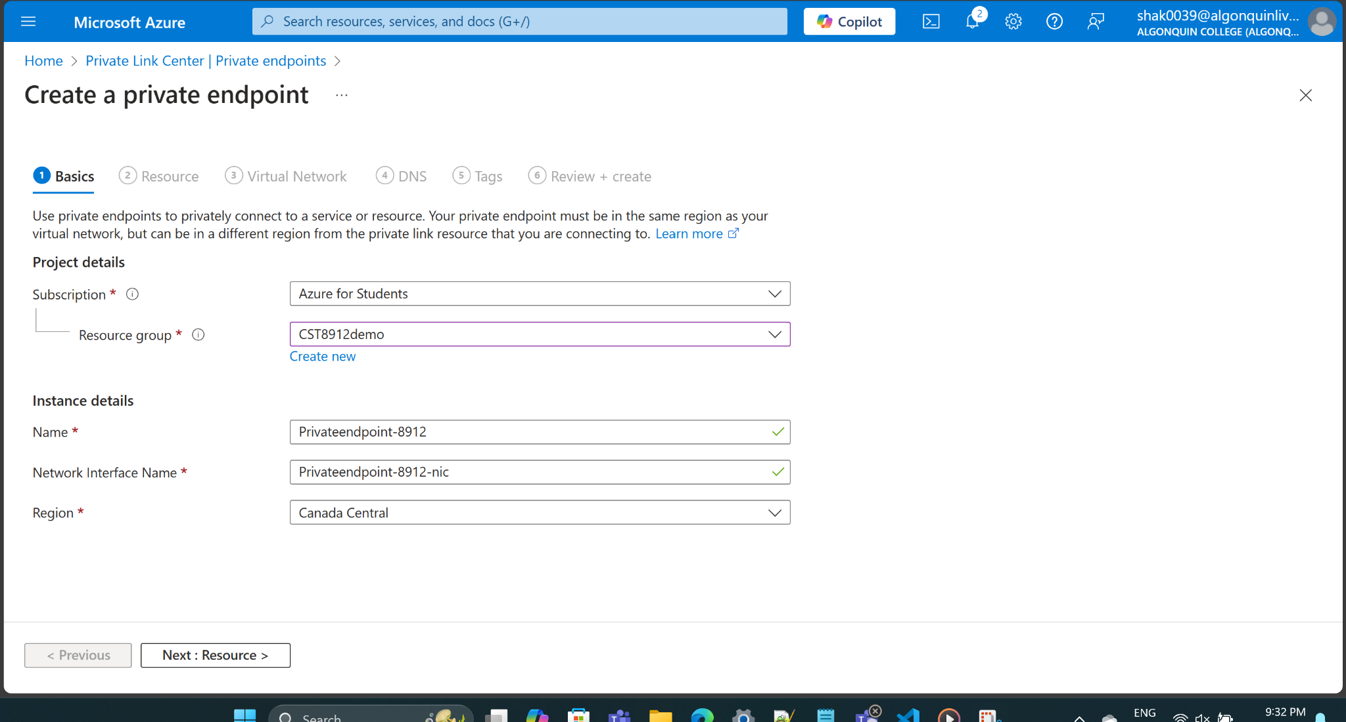

1. Select Next:Resource
2. In the Resource pane, enter or select the following information.

| **Setting** | **Value** |
| --- | --- |
| Connection method | Leave the default of Connect to an Azure resource in my directory. |
| Subscription | Select your subscription. |
| Resource type | Select Microsoft.Storage/storageAccounts. |
| Resource | Select Storage1-8912 or your storage account. |
| Target subresource | Select blob. |

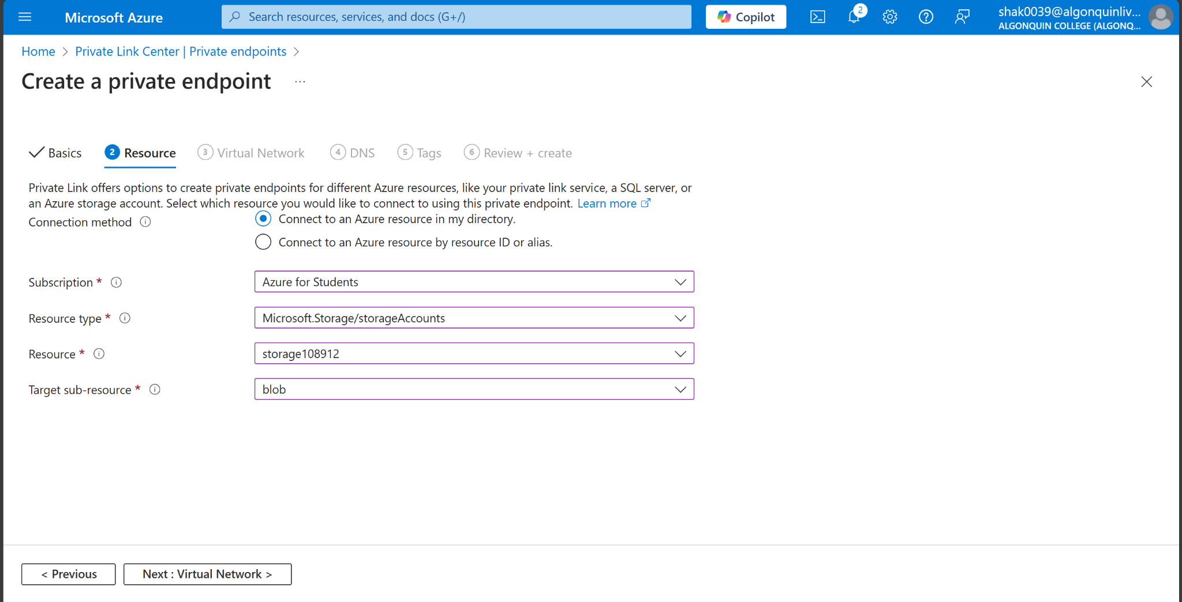

1. Select Next: Virtual Network.
2. In Virtual Network, enter or select the following information.

| **Setting** | **Value** |
| --- | --- |
| Virtual network | Select 8912-vnet (CST8912demo). |
| Subnet | Select Subnet-1-8912. |
| Network policy for private endpoints | Select edit to apply Network policy for private endpoints.  In Edit subnet network policy, select the checkbox next to Network security groups and Route Tables in the Network policies setting for all private endpoints in this subnet pull-down.  Select Save. |
| Private IP configuration | Select Dynamically allocate IP address. |

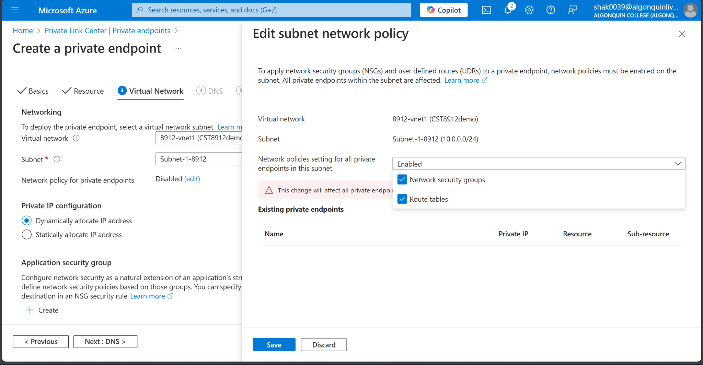

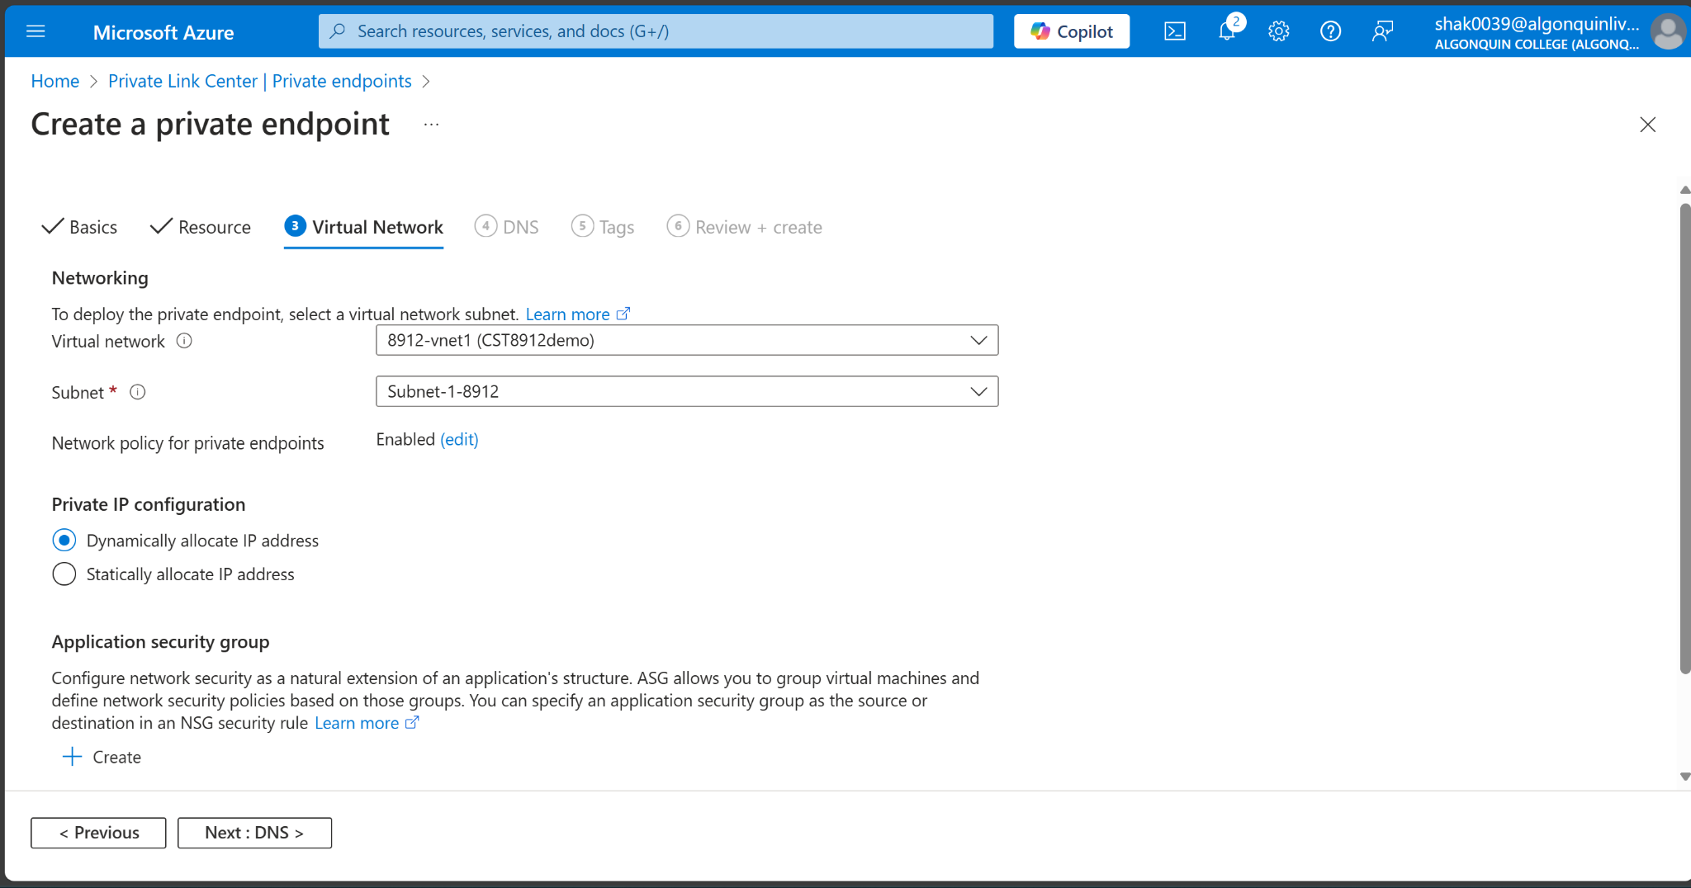

1. Select Next: DNS.
2. Leave the defaults in DNS. Select Next: Tags, then Next: Review + create.
3. Select Create.

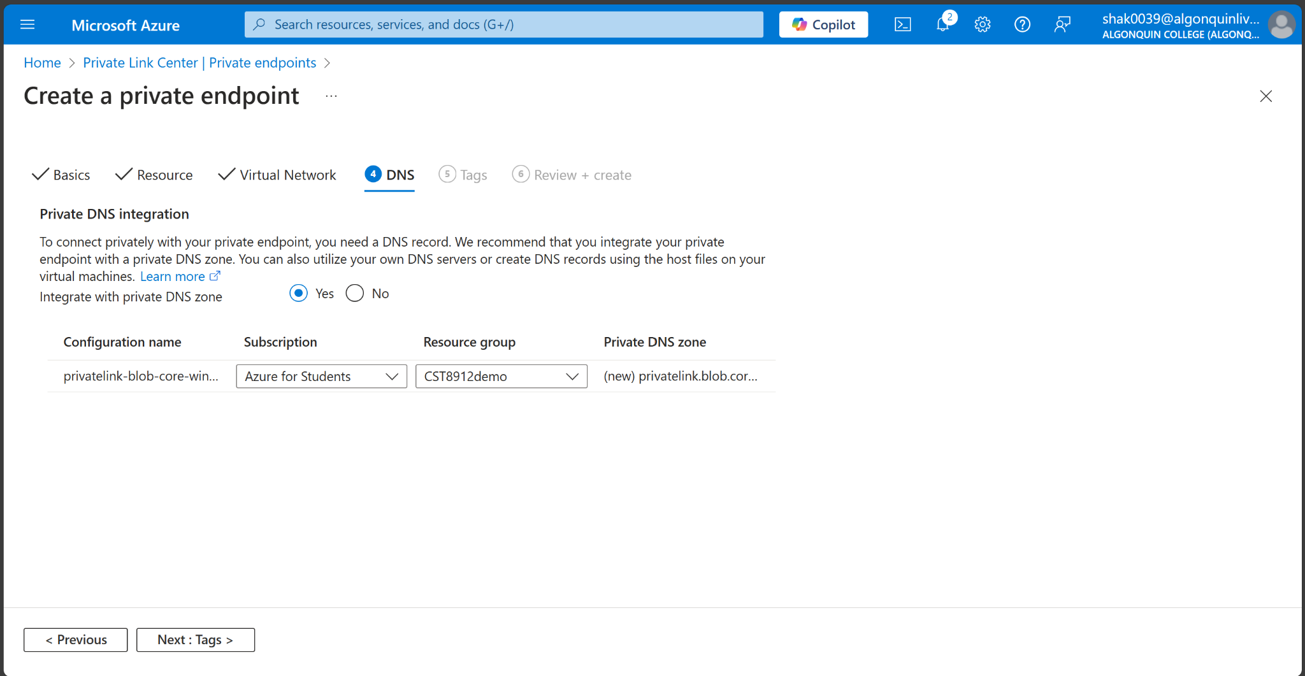

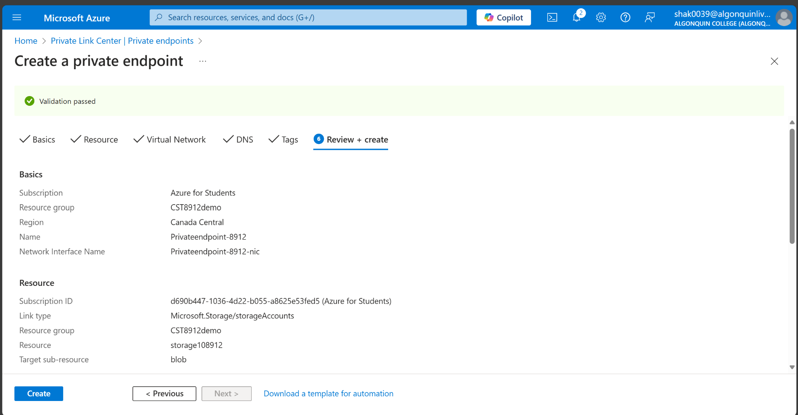

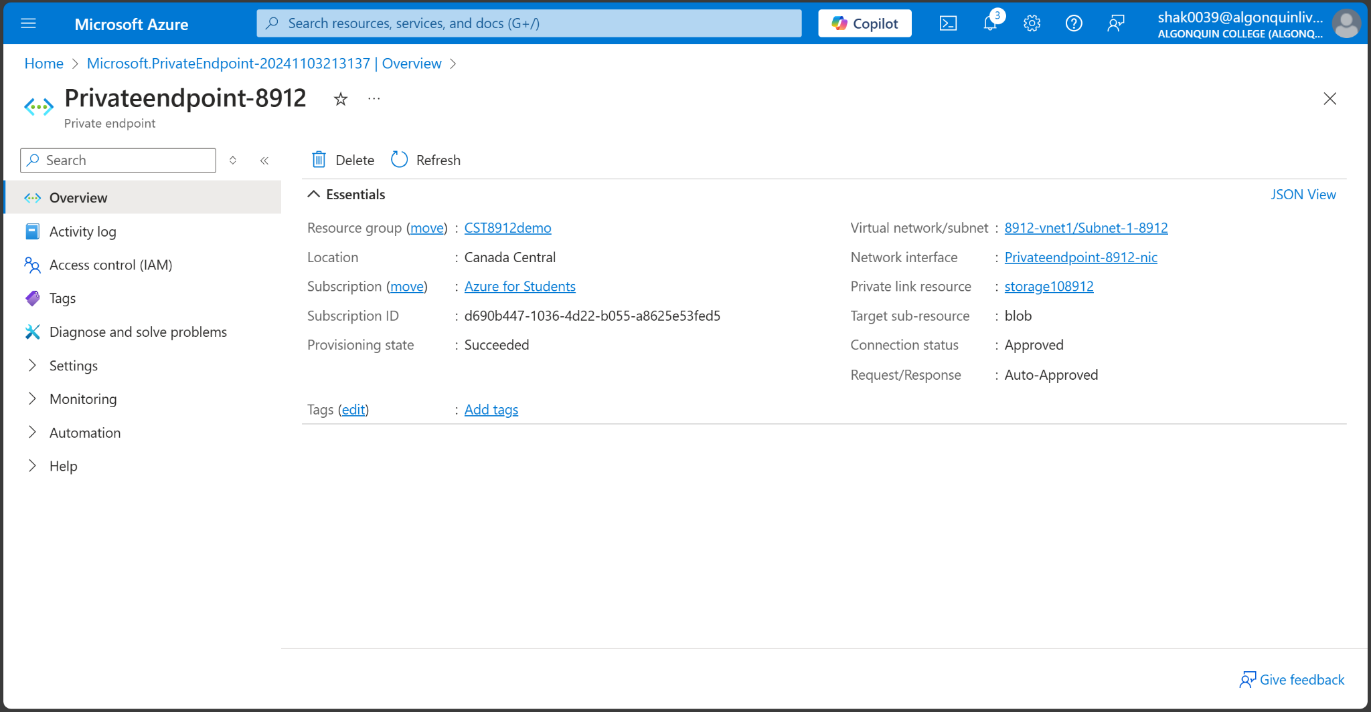

**Create test virtual machine**

1. In the portal, search for and select Virtual machines.

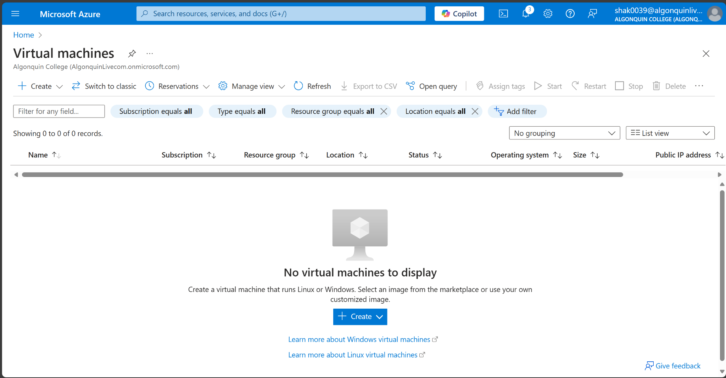

1. In Virtual machines, select + Create, then Azure virtual machine.
2. On the Basics tab of Create a virtual machine, enter or select the following information:

| **Setting** | **Value** |
| --- | --- |
| Subscription | Azure for students |
| Resource Group | CST8912demo |
| Virtual Machine name | 8912-VM1 |
| Region | Canada central |
| Availability options | No infrastructure redundancy required |
| Security type | Standard |
| Image | Select Windows Server 2022 Datacenter - x64 Gen2. |
| VM architecture | Leave the default of x64. |
| Size | Select size (B1) |
| Authentication | Choose username and password |
| Public inbound ports | Select None |

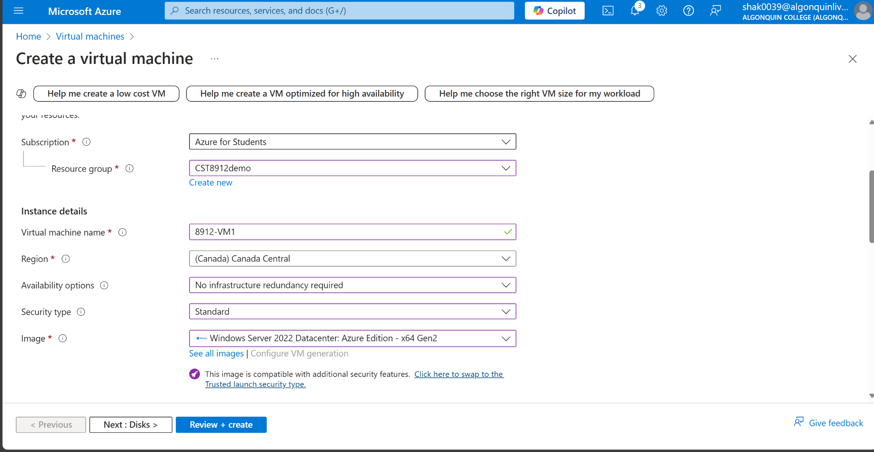

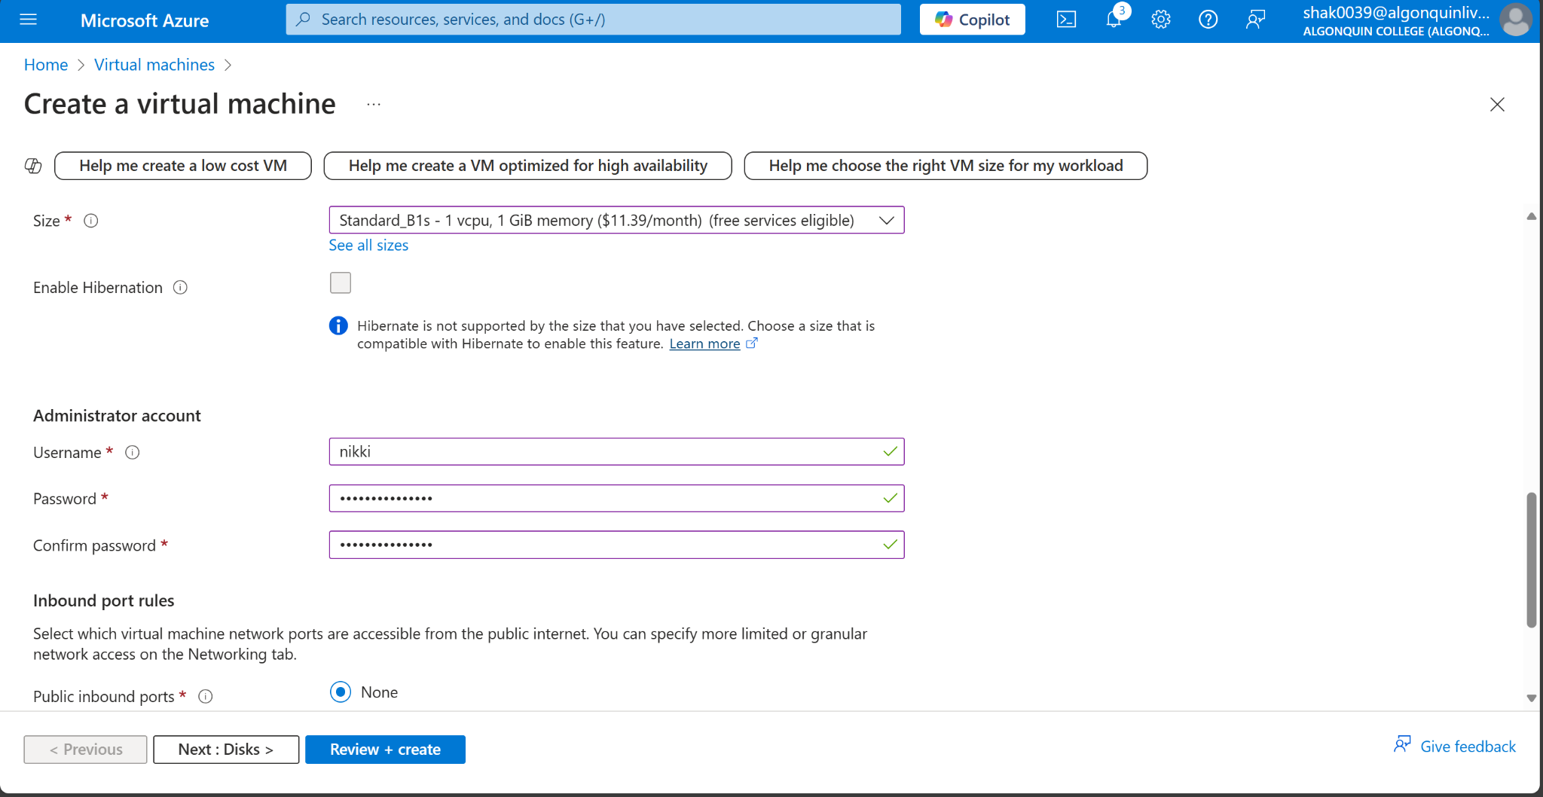

1. Select the Networking tab at the top of the page.
2. Enter or select the following information in the Networking tab:

| Setting | Value |
| --- | --- |
| Virtual Network | Select 8912-vnet (CST8912demo). |
| Subnet | Select Subnet-1-8912. |
| Public IP | Select None |
| NIC network security group | Select Advanced |
| Configure network security group | Select Create new.  Enter nsg-1 for the name.  Leave the rest at the defaults and select OK. |

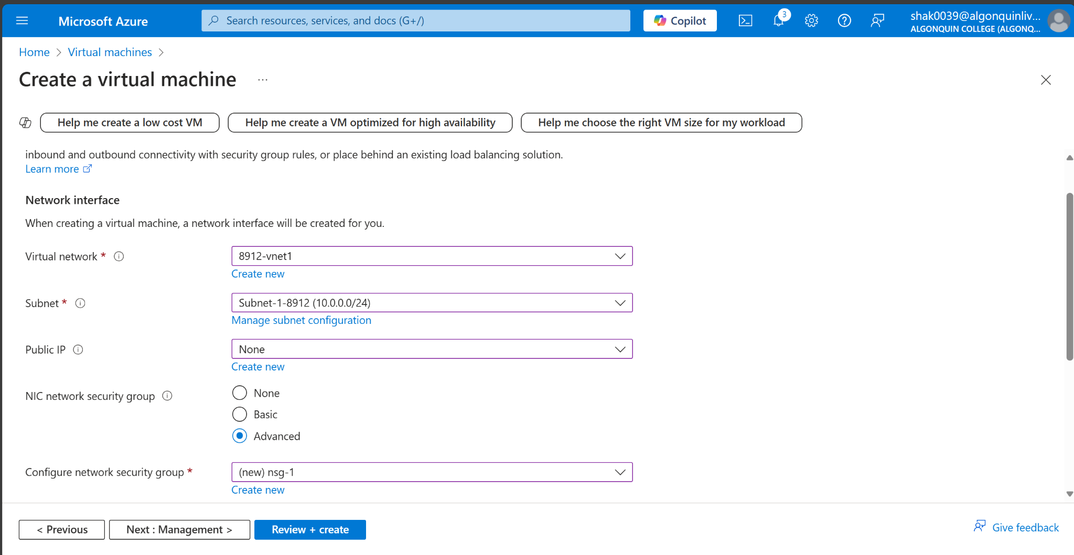

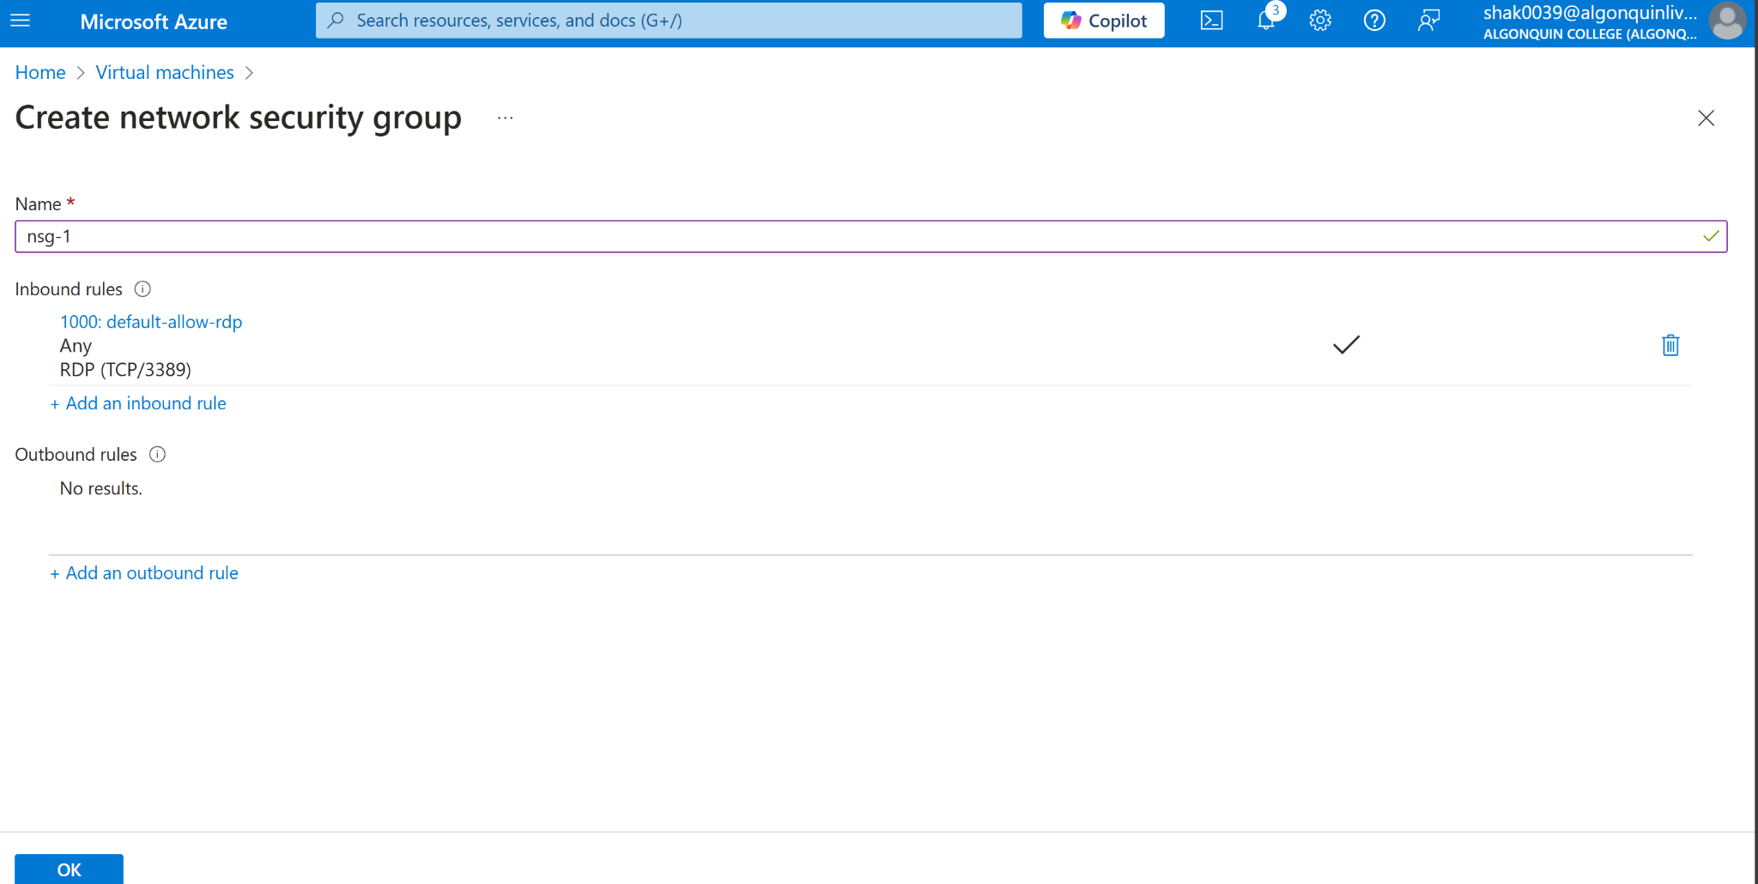

1. Leave the rest of the settings at the defaults and select Review + create.

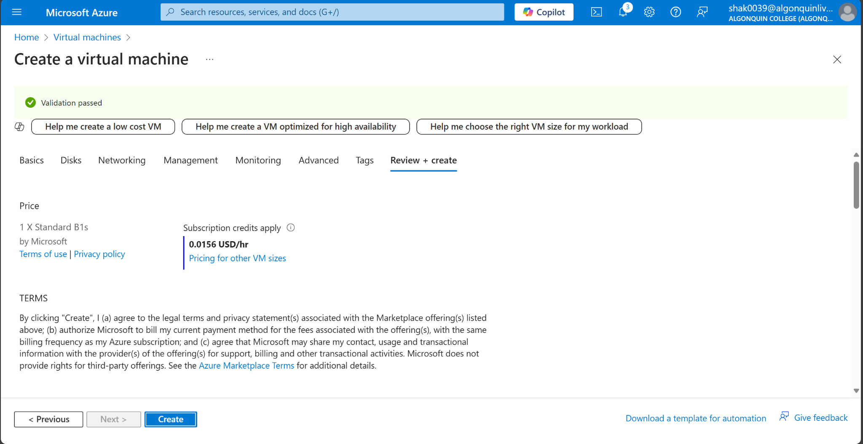

1. Review the settings and select Create.

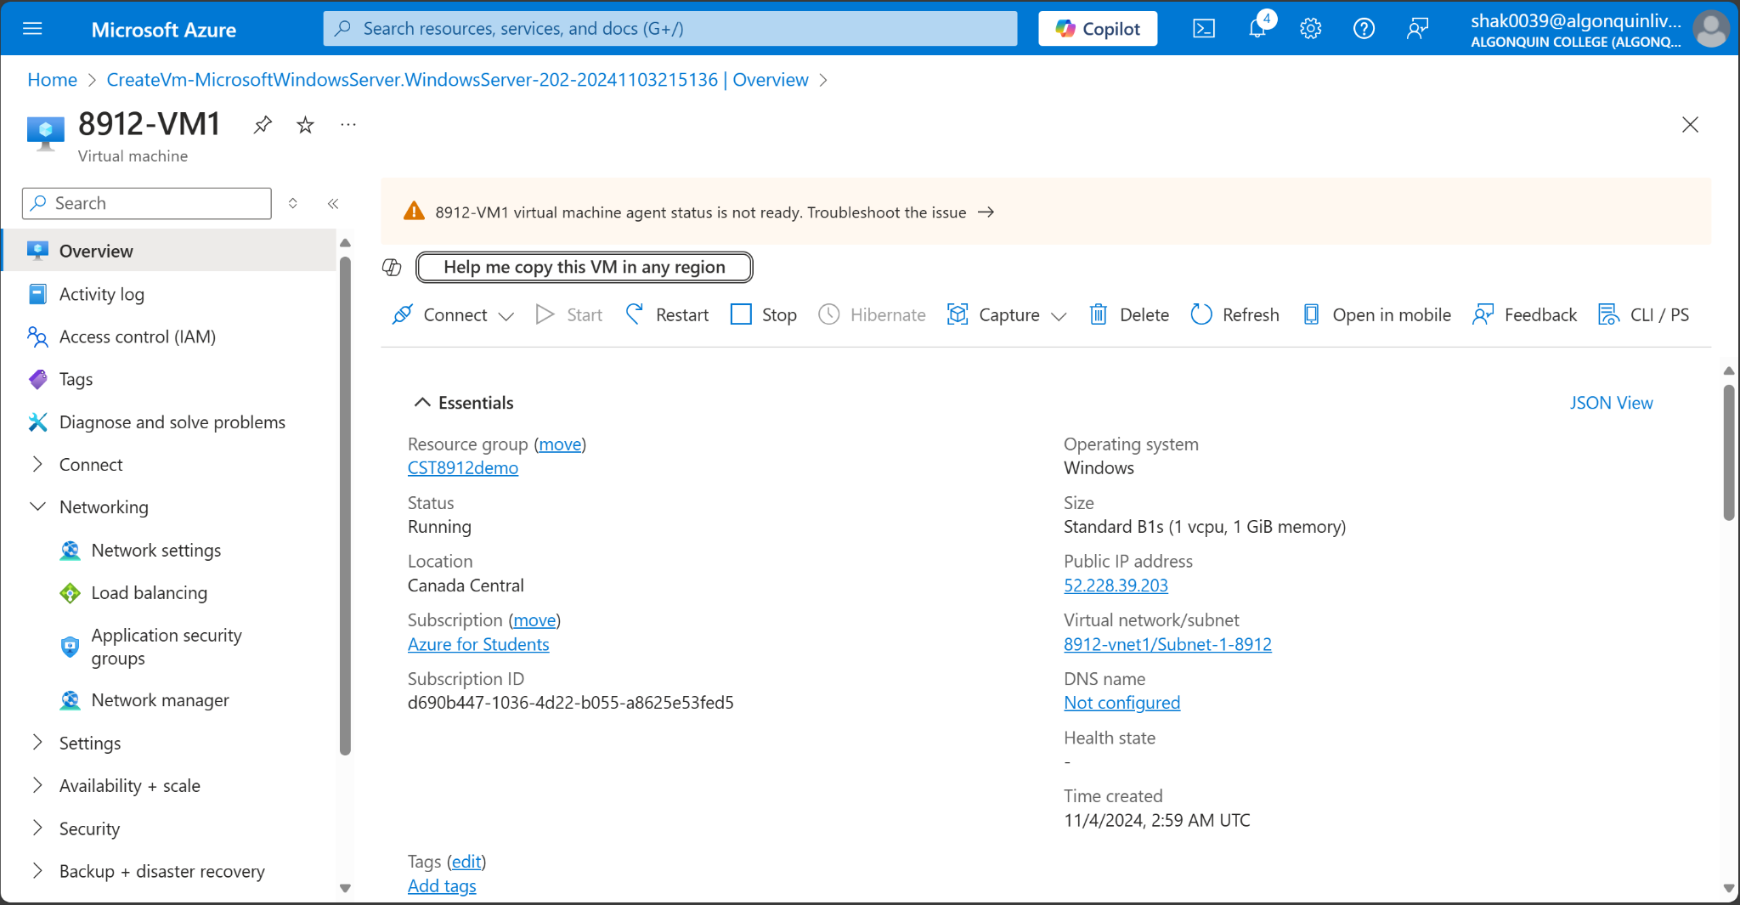

**Storage access key**

1. In the search box at the top of the portal, enter Storage account. Select Storage accounts in the search results.
2. Select the storage account you created in the previous steps or your existing storage account.
3. In the Security + networking section of the storage account, select Access keys.

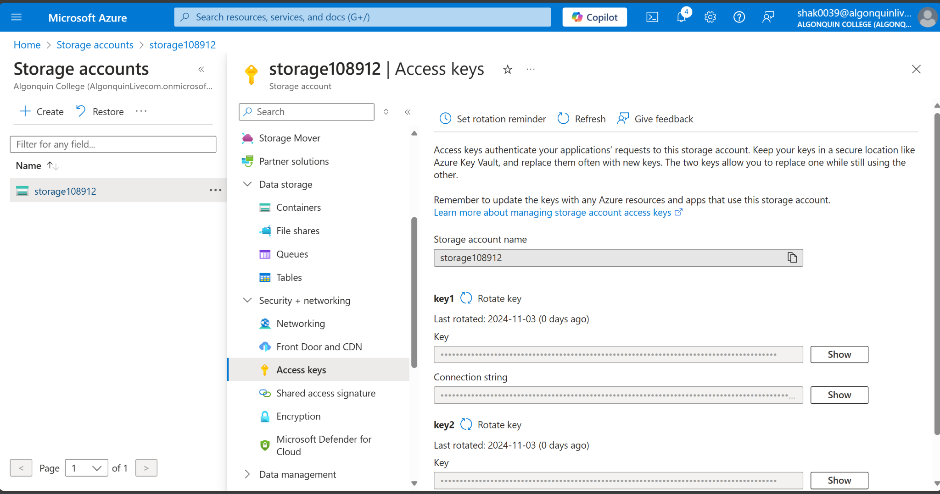

1. Select Show, then select copy on the Connection string for key1.

MTJcdVk8shCVOic74js3eUiHJ/7wb4UWKPUw6WtdfRpMSoBir3vuNXVgkb8bSHV8O0dOW+SYpIVI+AStvDWOhg==

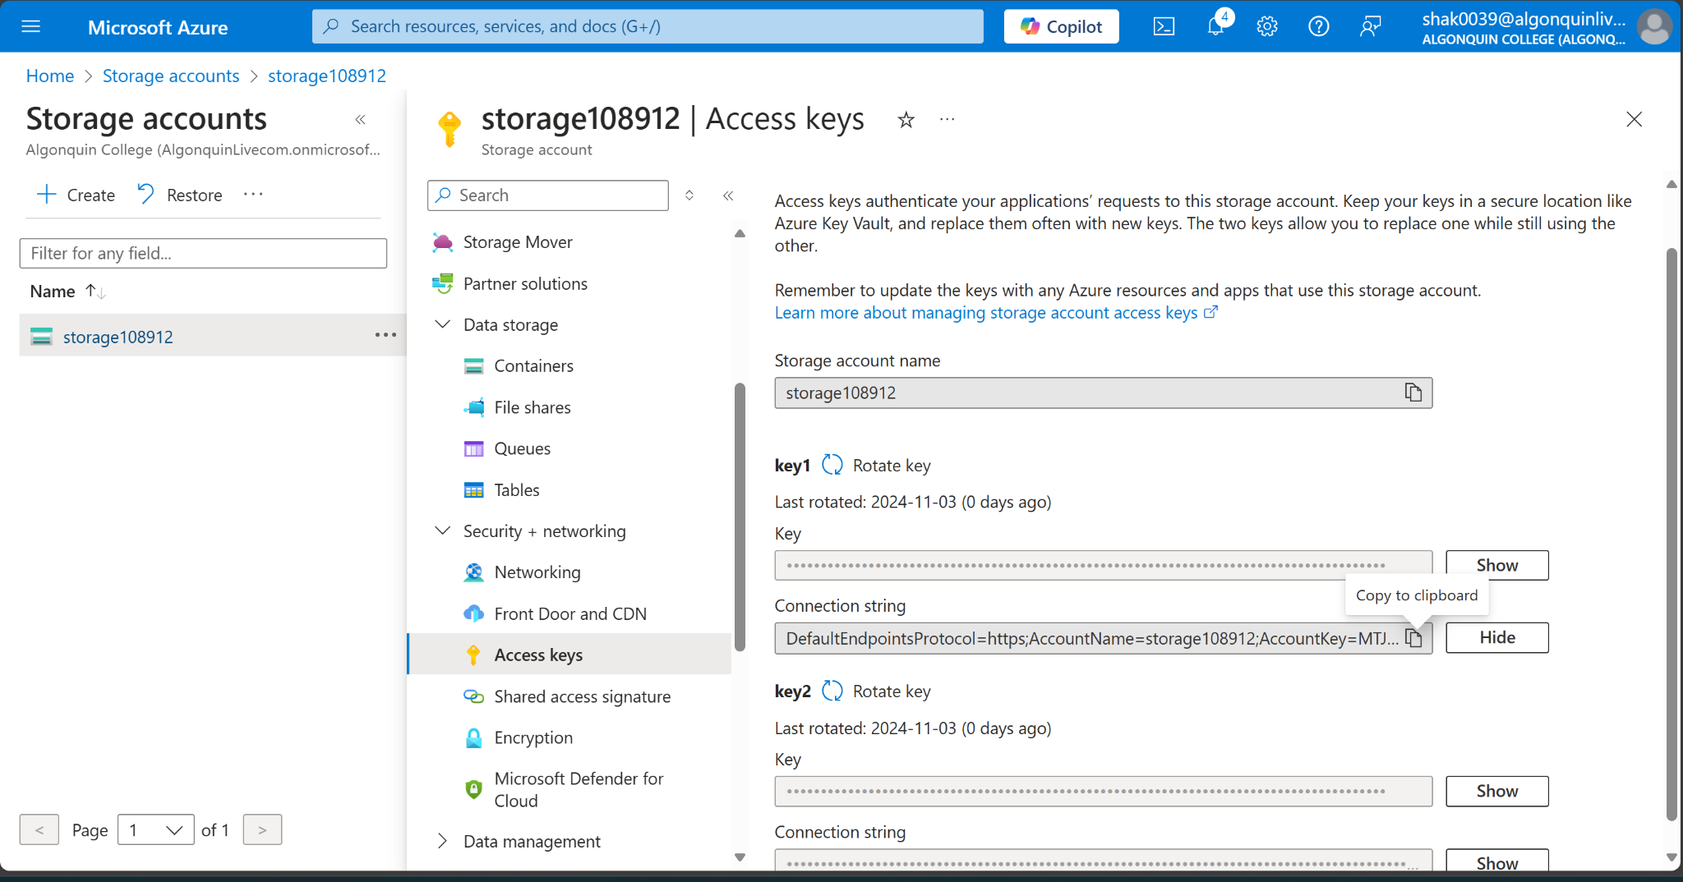

**Add a blob container**

1. In the search box at the top of the portal, enter Storage account. Select Storage accounts in the search results.
2. Select the storage account you created in the previous steps.
3. In the Data storage section, select Containers.
4. Select + Container to create a new container.
5. Enter container in Name and select Private (no anonymous access) under Public access level.

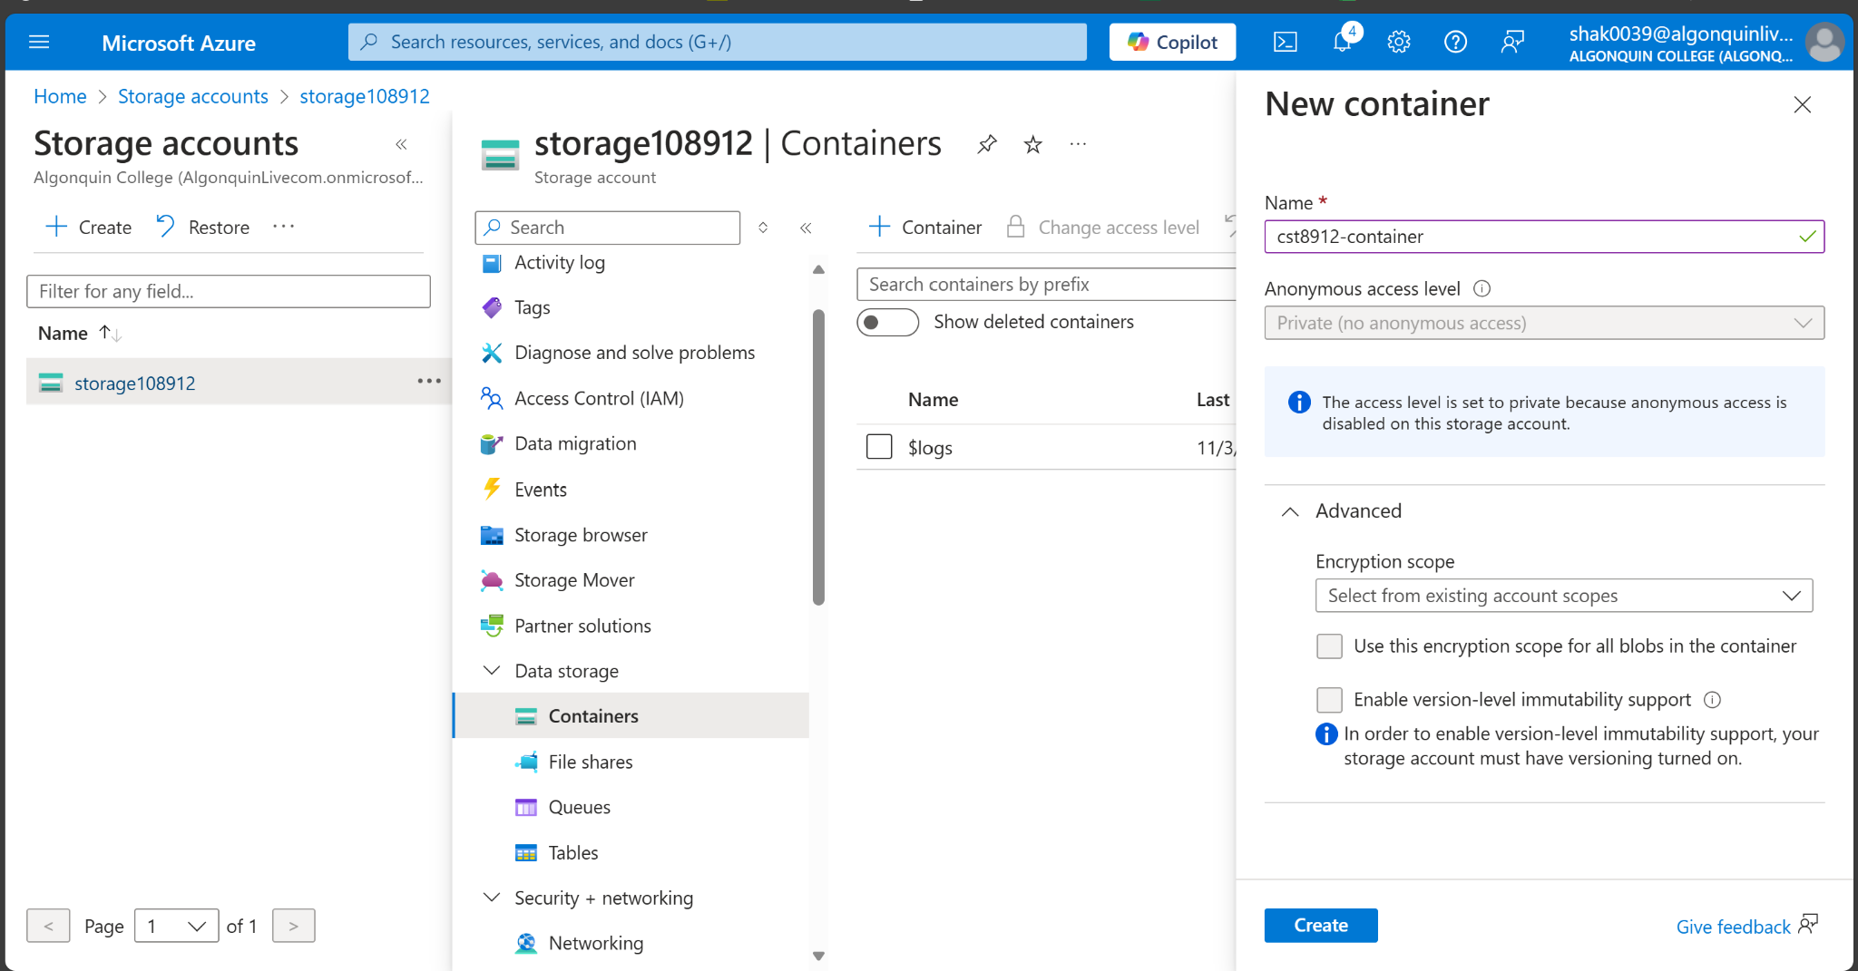

1. Select Create.

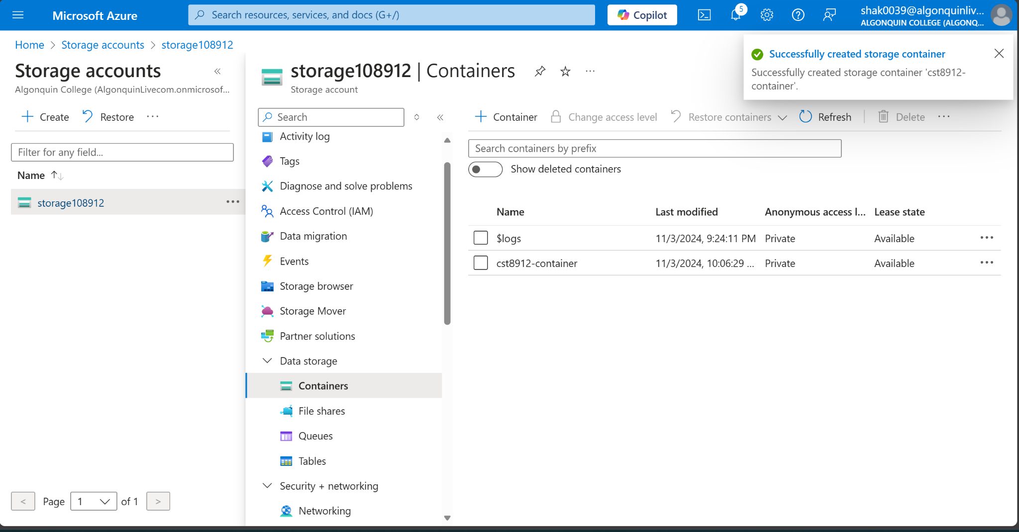

**Test connectivity to private endpoint**

1. In the search box at the top of the portal, enter Virtual machine. Select Virtual machines in the search results.
2. Select 8912-VM1.

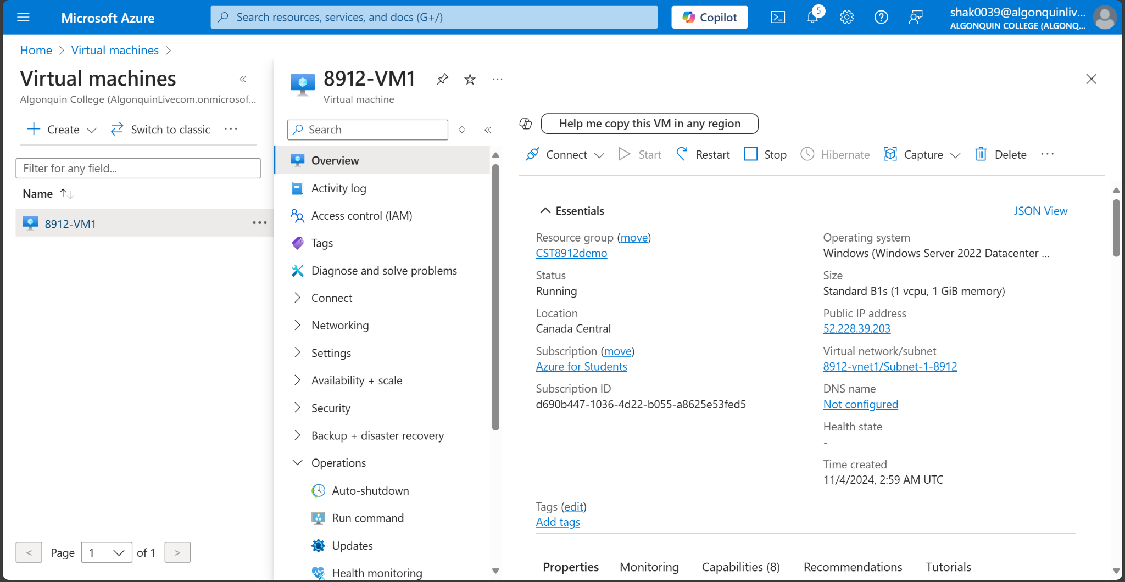

1. In Operations, select Bastion.
2. Enter the username and password that you entered during the virtual machine creation.

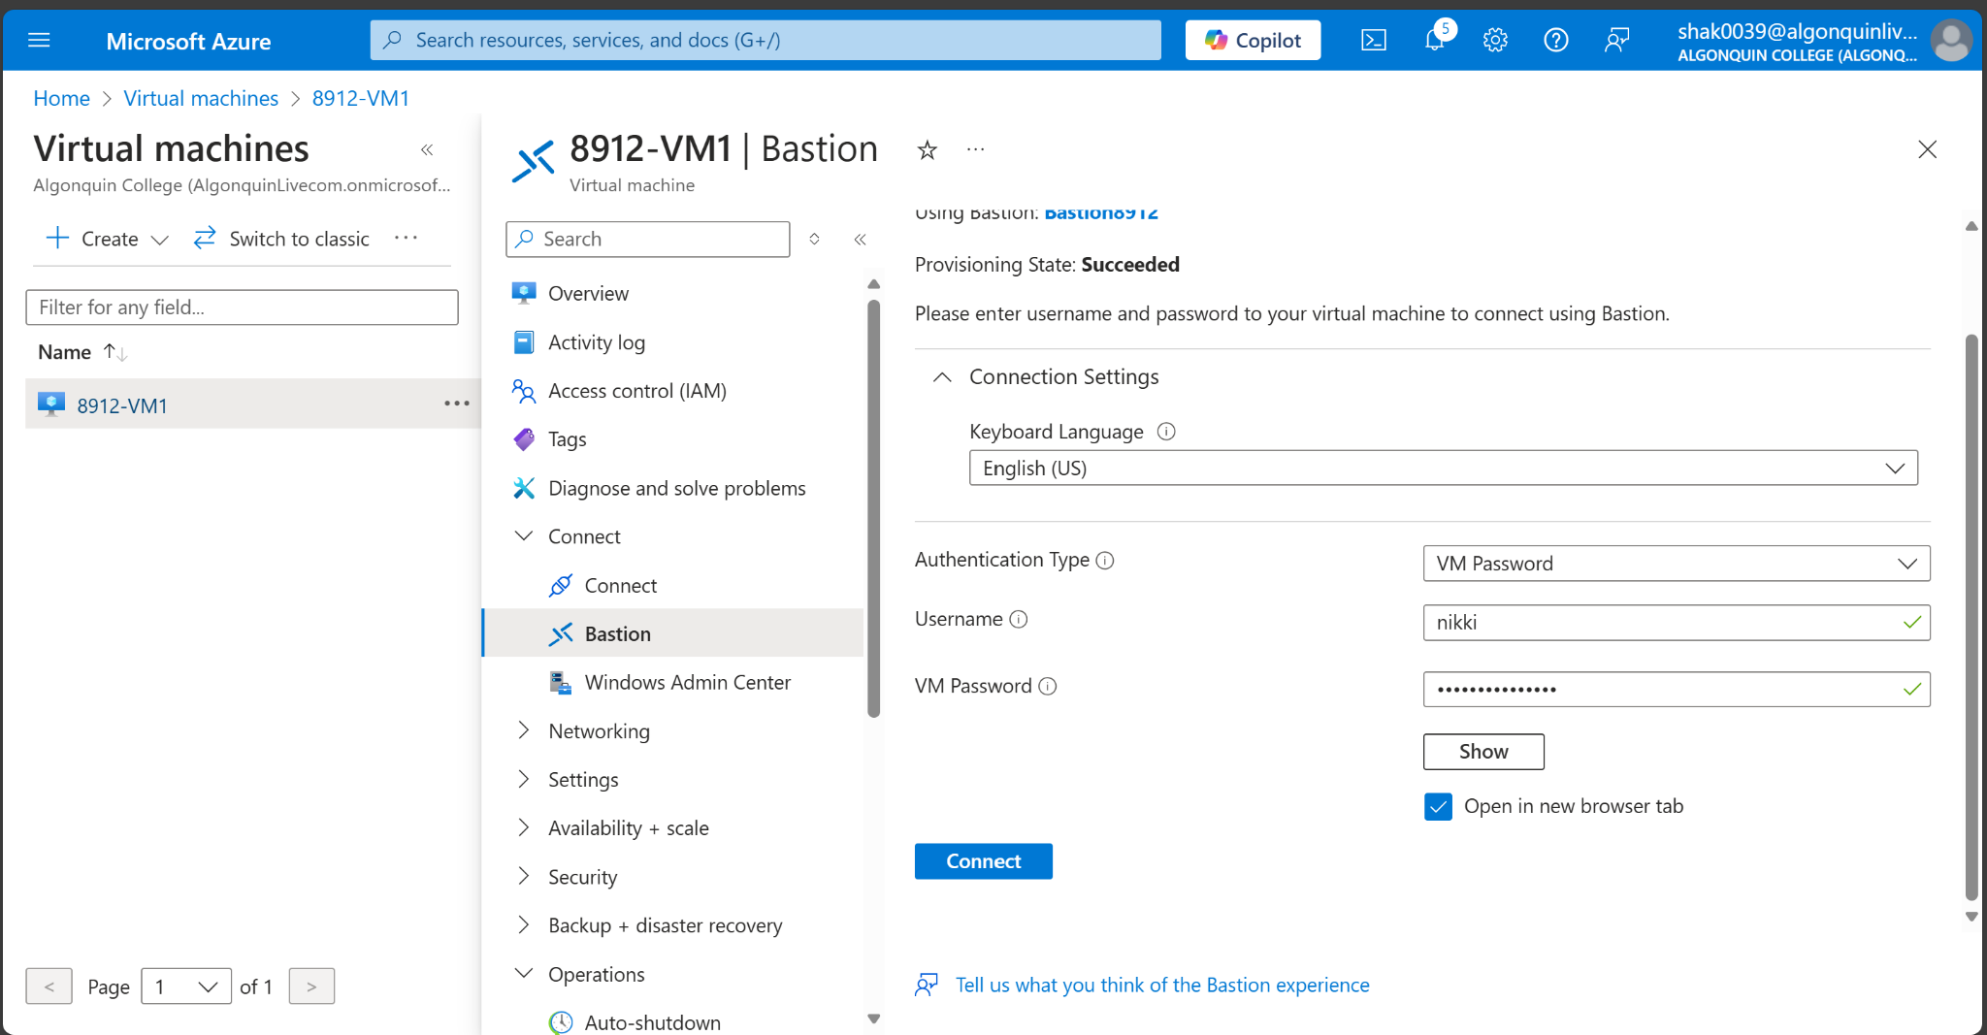

1. Select Connect.

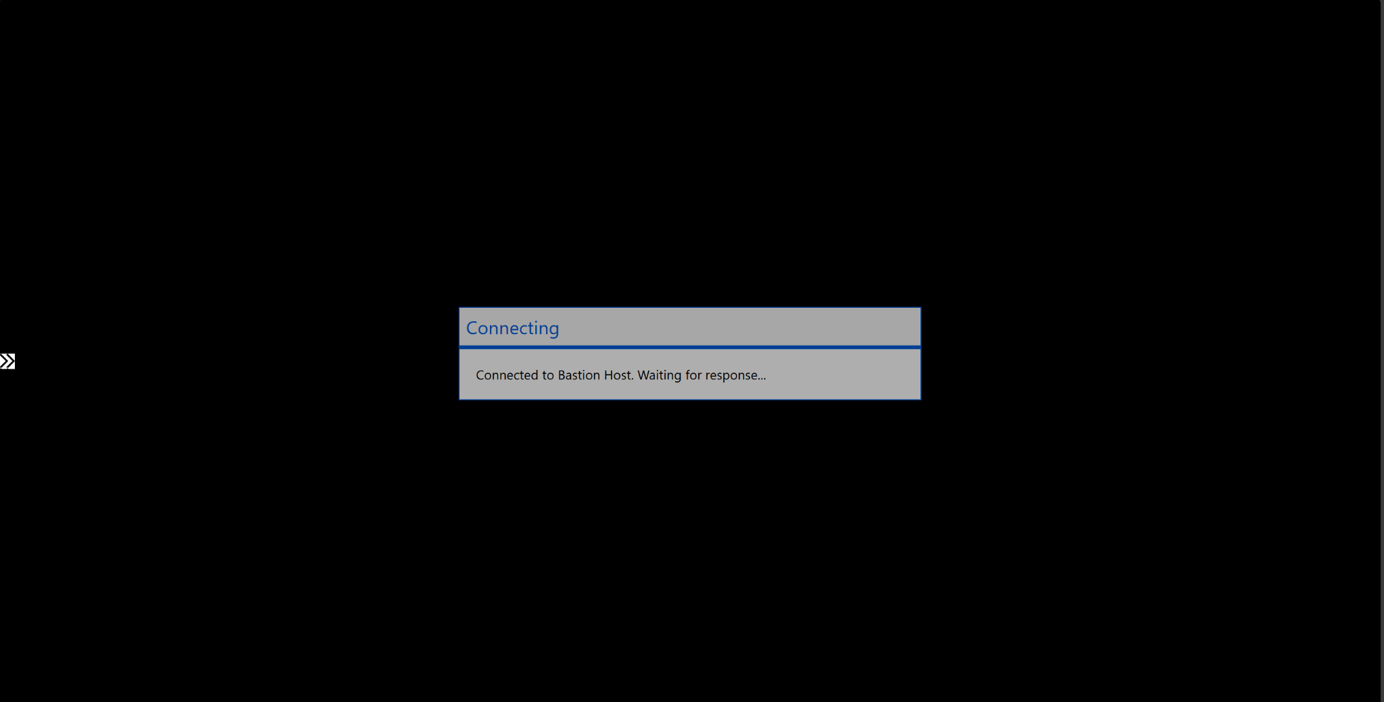

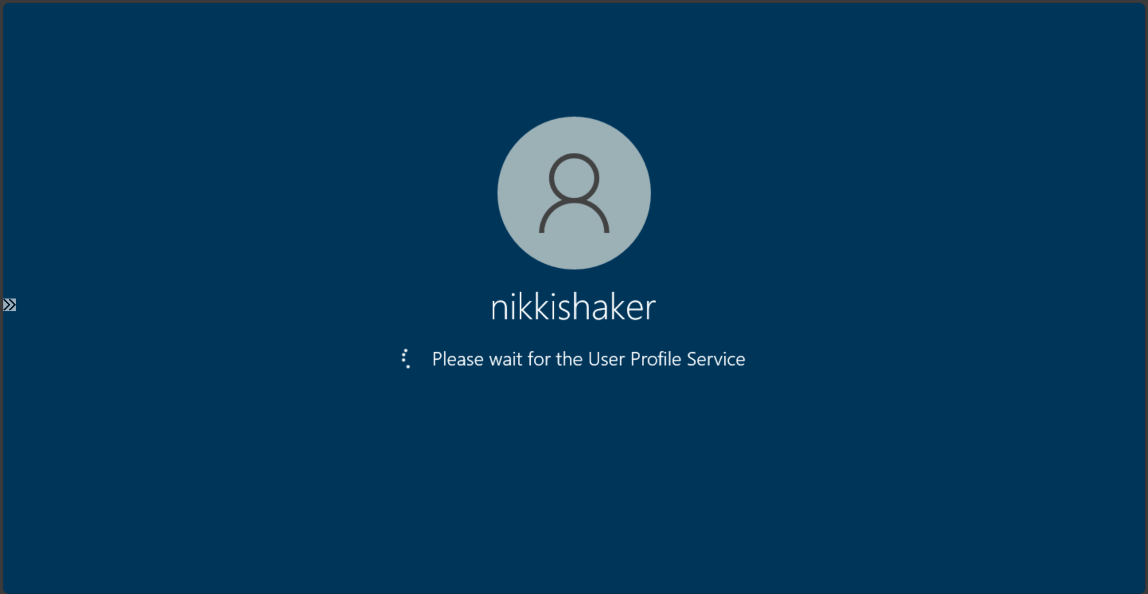

1. Open Windows PowerShell on the server after you connect.
2. Enter nslookup <storage-account-name>.blob.core.windows.net. Replace <storage-account-name> with the name of the storage account you created in the previous steps. The following example shows the output of the command.

Server: UnKnown

Address: 168.63.129.16

Non-authoritative answer:

Name: storage1.privatelink.blob.core.windows.net

Address: 10.0.0.10

Aliases: mystorageaccount.blob.core.windows.net

A private IP address of 10.0.0.10 is returned for the storage account name. This address is in Subnet-1-8912 subnet of 8912-vnet virtual network you created previously.

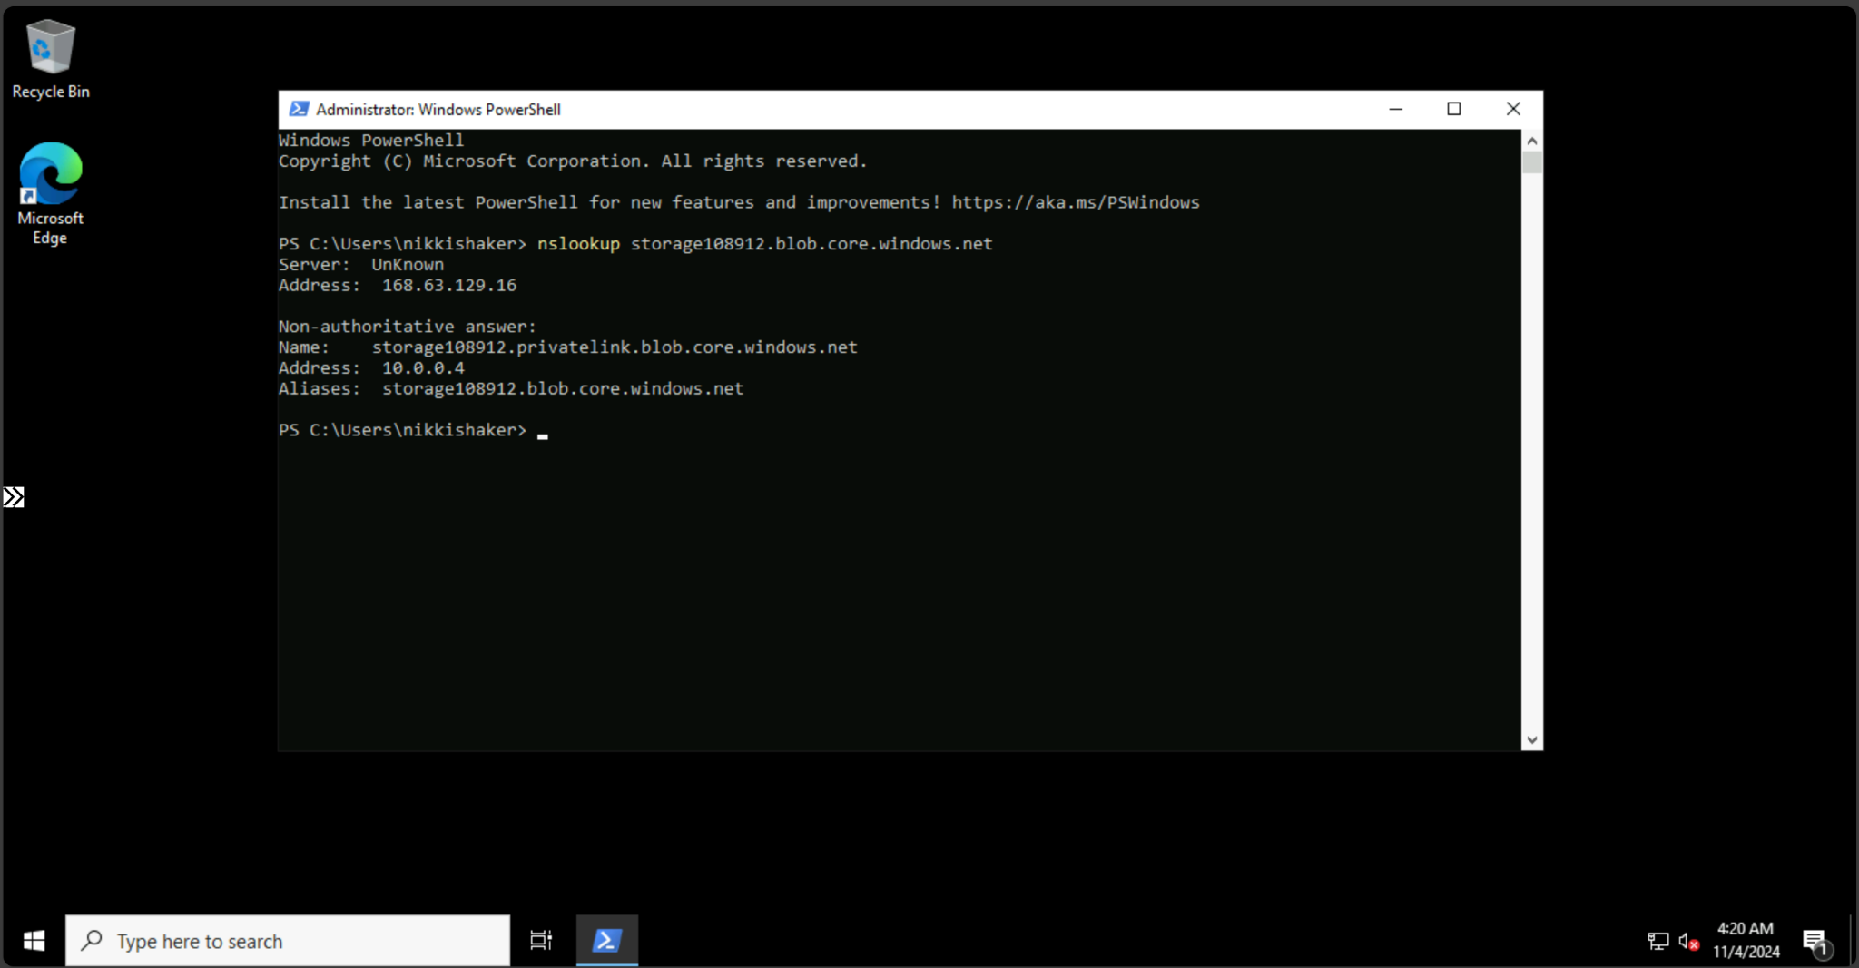

1. Install Microsoft Azure Storage Explorer on the virtual machine.

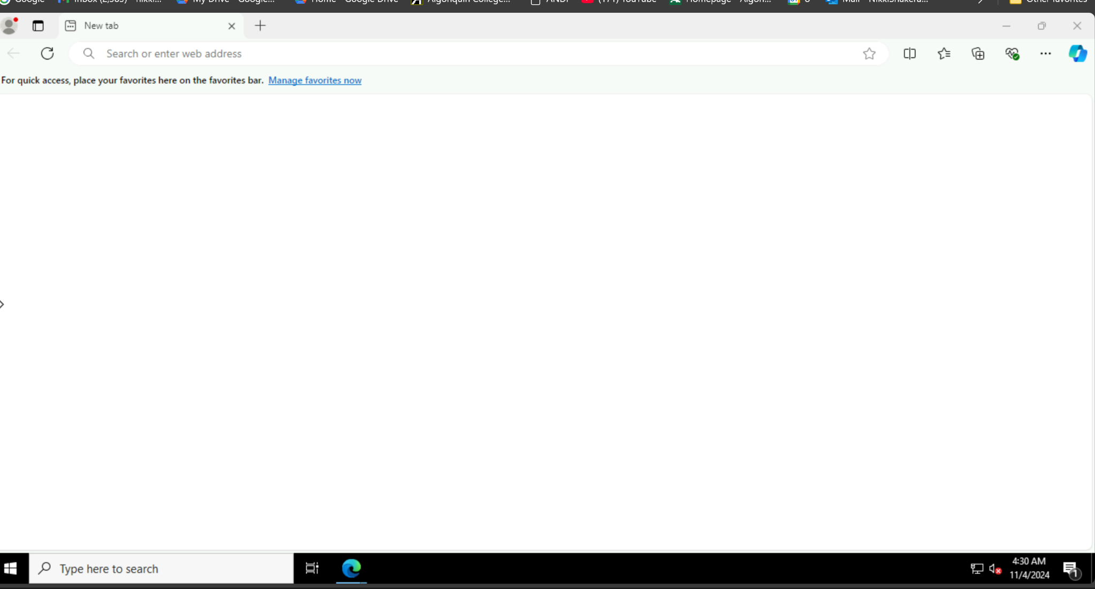

1. Select Finish after the Microsoft Azure Storage Explorer is installed. Leave the box checked to open the application.

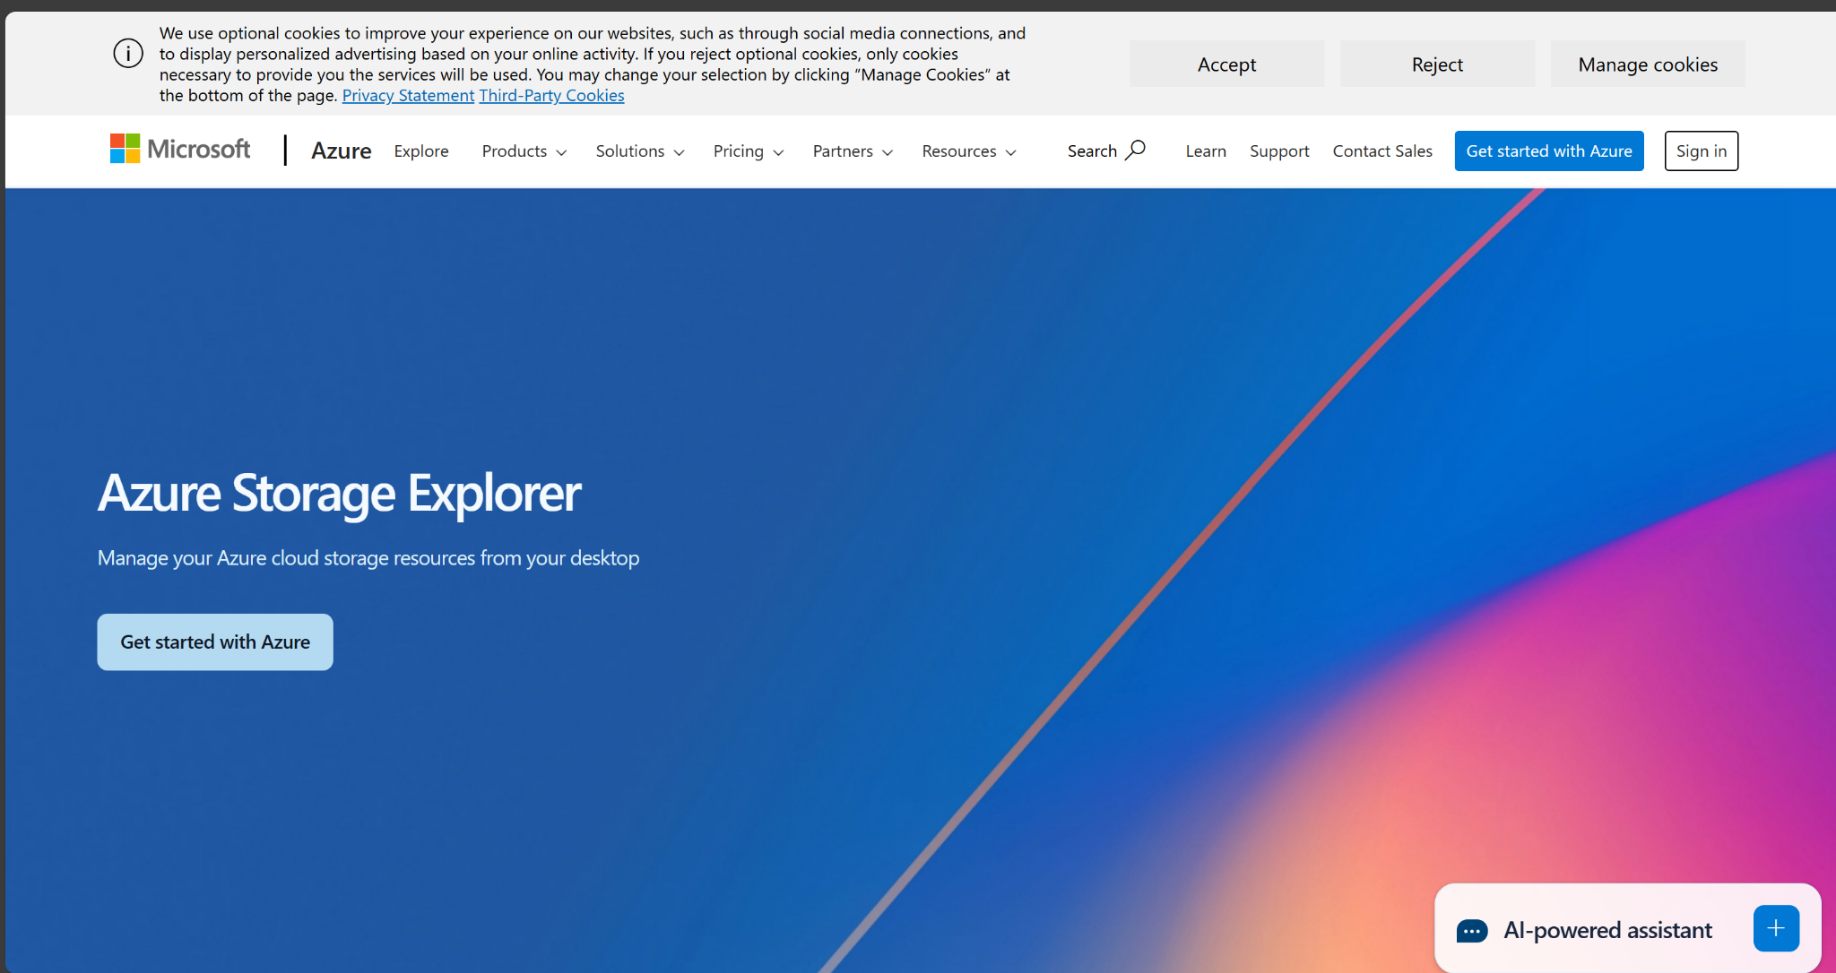

1. Select the Power plug symbol to open the Select Resource dialog box in the left-hand toolbar.
2. In Select Resource , select Storage account or service to add a connection in Microsoft Azure Storage Explorer to your storage account that you created in the previous steps.
3. In the Select Connection Method screen, select Connection string, and then Next.
4. In the box under Connection String, paste the connection string from the storage account you copied in the previous steps. The storage account name automatically populates in the box under Display name.
5. Select Next.
6. Verify the settings are correct in Summary.
7. Select Connect
8. Select your storage account from the Storage Accounts in the explorer menu.
9. Expand the storage account and then Blob Containers.
10. The container you created previously is displayed.
11. Close the connection to 8912-VM1.
12. Clean all the resources created during the lab and document all the steps using screenshots and paste that in the lab report.

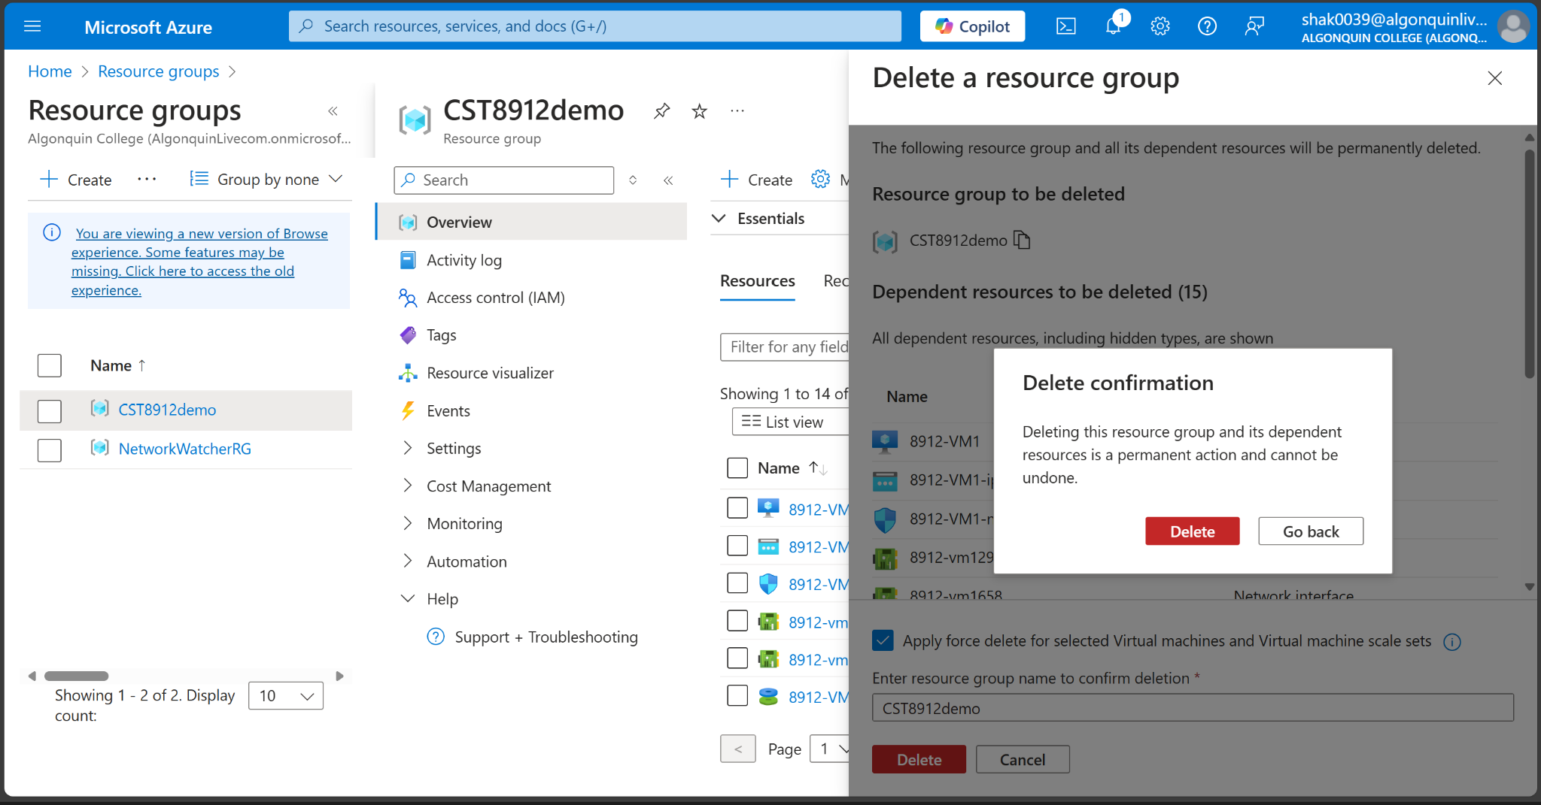

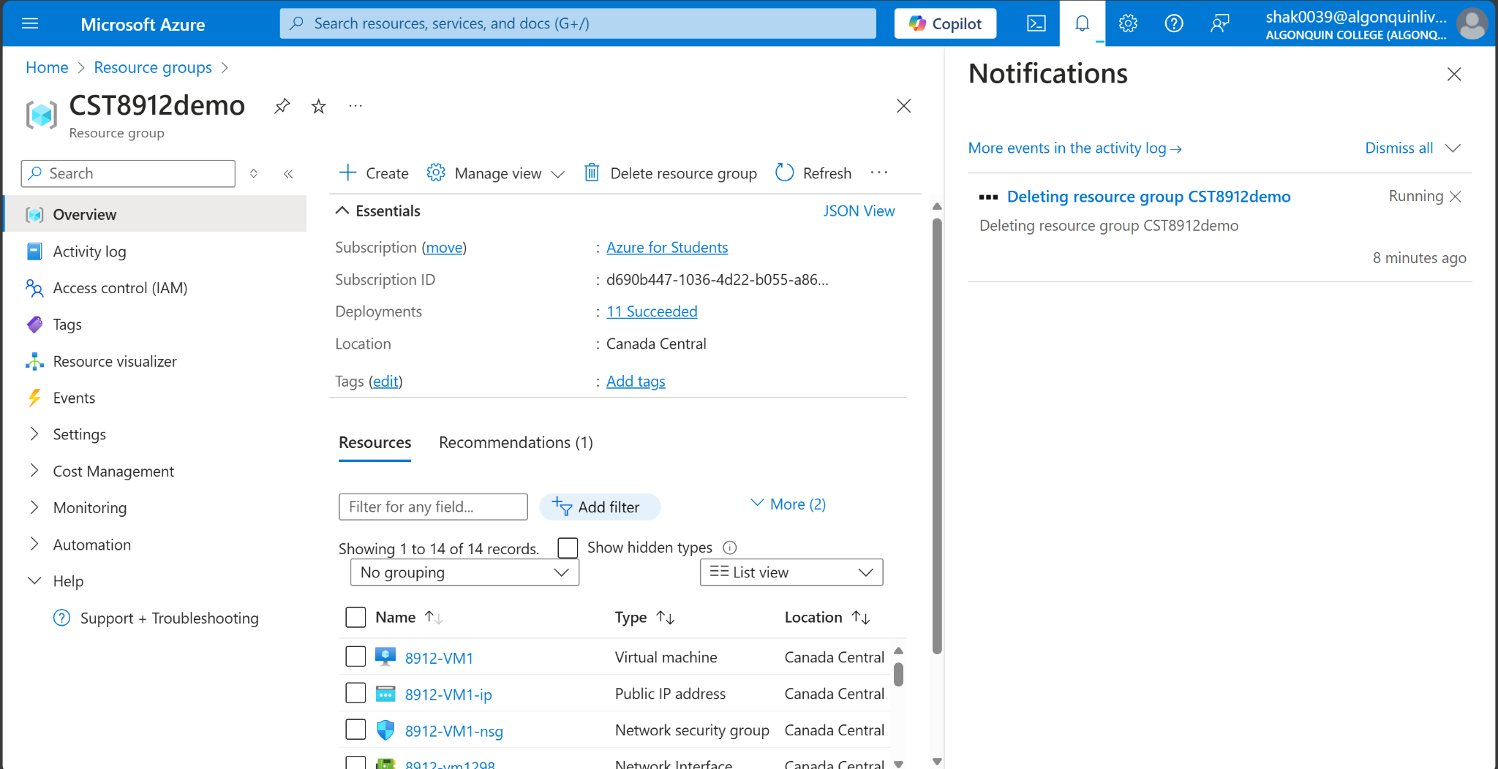

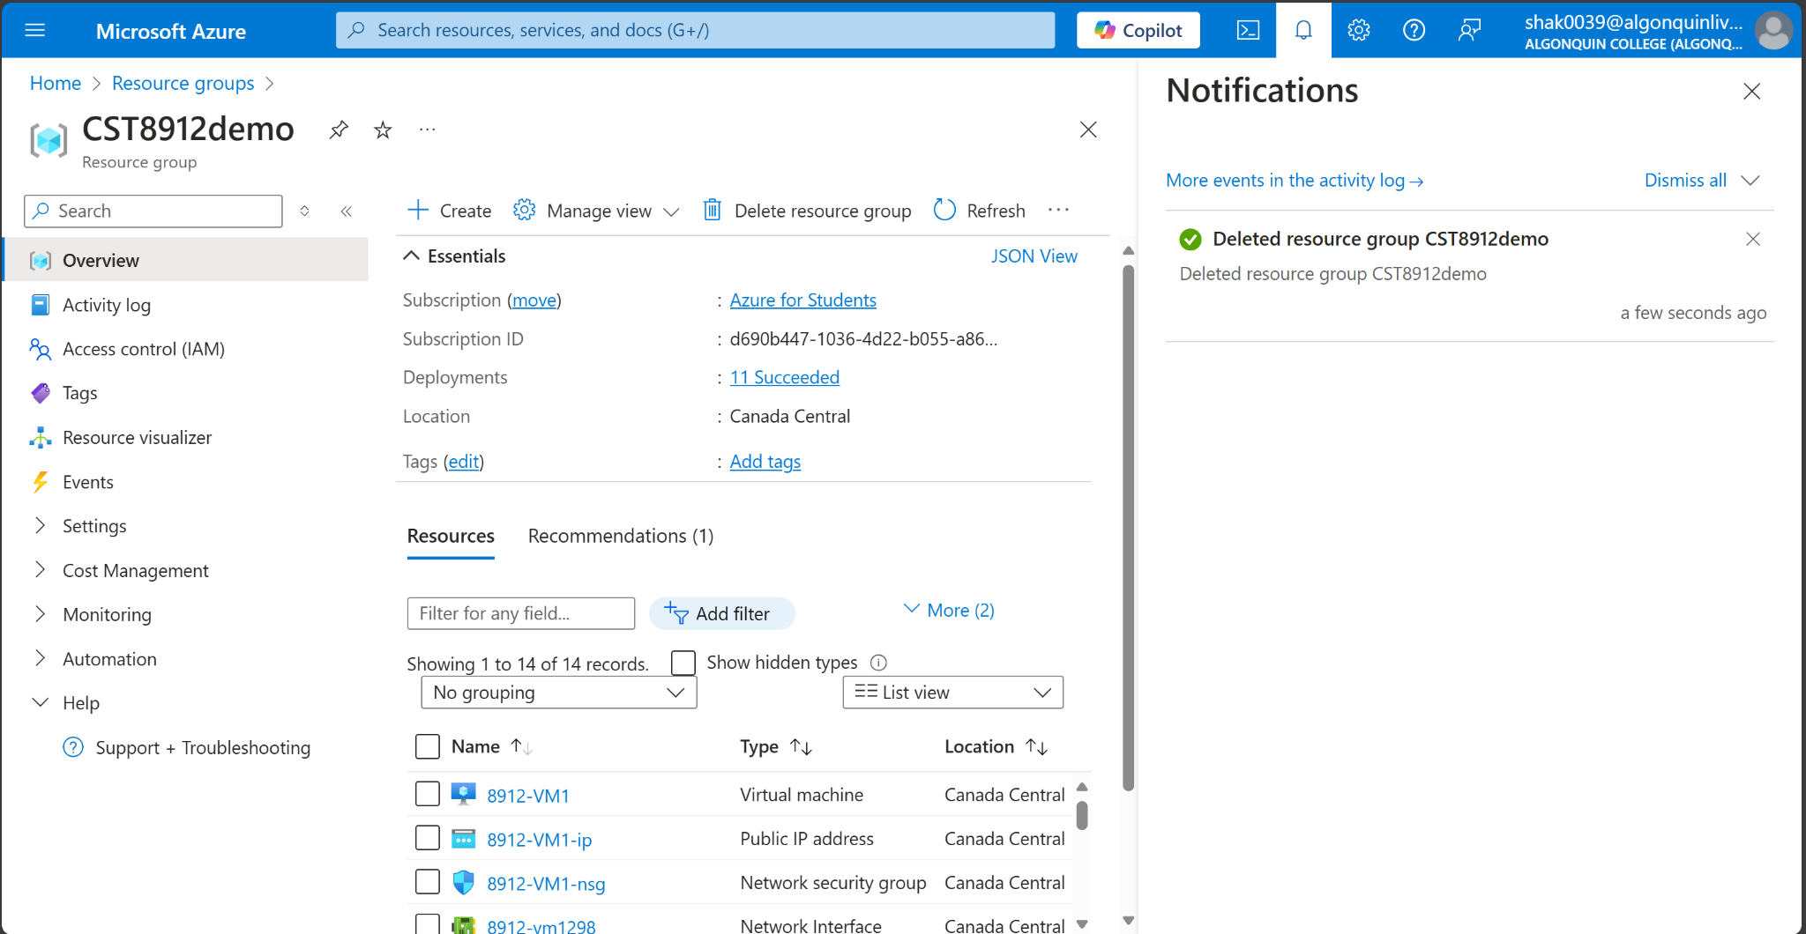

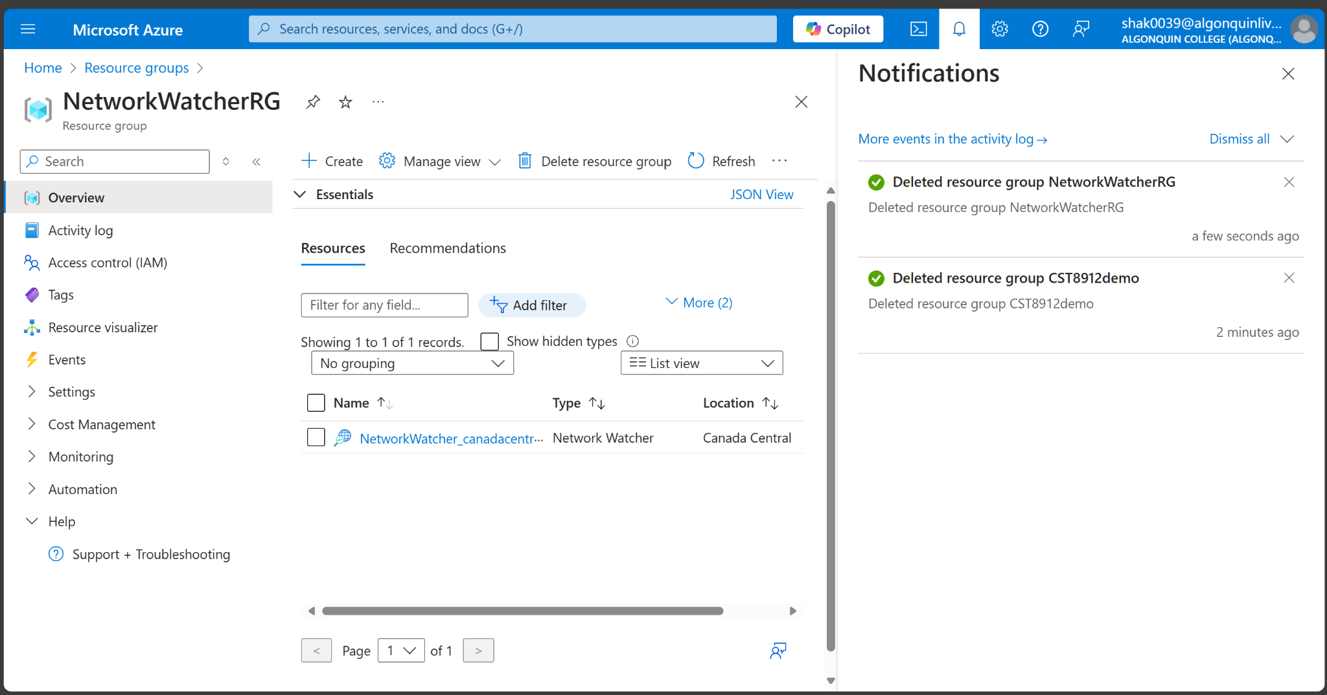

**Lab Report**

This lab focused on configuring and testing Azure Private Link to securely connect virtual networks to Azure resources without exposing data to the internet. First, I created a virtual network, Bastion Host, and storage account. Then, I disabled public access to the storage account, and set up a private endpoint to establish private connectivity. A test virtual machine was created and connected using Azure Bastion; however, I had connectivity issues, because of a popup blocker that caused a login failure error, which I was able to fix by making changes to the popup blocker. A test virtual machine was created and connected using Azure Bastion, and in order to verify secure access to the storage account, I used a private IP using PowerShell. I also used Microsoft Azure Storage Explorer to confirm blob storage connectivity through the private endpoint. Finally, I cleaned up resources to avoid costs, which shows how the Azure Private Link enhances security and network architecture by facilitating secure, private access to Azure PaaS services.